SANDBOX DOCUMENTATION
(ABDM_Milestone 2)
Version 2.7
Created On 13.12.2024

- Base URL 4
- Terminology Definition 4
- Gateway 4
  - Overview 4
  - List of APIs 4
    - Auth token API 4
    - OpenID Configuration API. 7
    - Keycloak Certificate API 7
    - Update bridge URL API 10
    - Registration of Facility & Software Linkage 11
    - Find bridge by service id 13
    - Find services by bridge id 15
- HIP Initiated Linking 18
  - Overview 18
  - Sequence Diagram 19
  - List of APIs 20
    - Link token generation 20
    - Callback API for Link token generation 25
    - Linking care context 33
    - Call back API for linking care context with patient ABHA address 39
    - Get all patient links 42
    - Notify care context update 45
    - Call back API for notify care context update 49
    - SMS Notification to patients 51
    - Callback API for SMS Notification to patients 54
- User Initiated Linking 56
  - Overview 56
  - Sequence Diagram 58
  - List of APIs 60
    - Patient Health record discovery 60
    - HIE-CM callback to HIP - Discovery 63
    - HMIS/LMIS response on health record discover 65
    - HIE-CM callback on Health record discover 72
    - Patient health record link init 74
    - HIE-CM callback on health record link init 79
    - HMIS/LMIS response on health record link 81
    - HIE-CM response on health record link 86
    - Patient health record confirm 89
    - HIE-CM callback for health record confirmation 92
    - HMIS/LMIS response on health record confirm 93
    - HIE-CM response on health record on-confirm 96
- Data Flow 98
  - Overview 98
  - Sequence Diagram 99
  - List of APIs 99
    - Callback API to HIP when a consent request is APPROVED/REVOKED 99
    - HIP to respond back to consent HIP notify 103
    - Data Flow - Health information request – Callback to HIP 105
    - HIP acknowledgement to the health information request 108
    - HIP calling data push URL 109
    - Health Information notify API 111
- Scan and Profile Share 114
  - Overview 114
  - Sequence Diagram 115
  - List of APIs 115
    - Profile share 115
    - Profile share – Callback 119
    - Profile on-share 122
    - Profile on share – Callback 124
- API Listing 127
- Error Codes Listing 130

Base URL and X-CM-ID
Environment | Base URL | X-CM-ID
Sandbox | https://dev.abdm.gov.in | Sbx
Production | https://apis.abdm.gov.in | Abdm

Terminology Definition:
Bridge ID: Is client ID which provided by NHA to HIP (Its alphanumerical eg: SBX_00XXXX)
Service ID: Is Facility ID which is generated from NHPR application (Its alphanumeric eg: IN02100000XX)

Gateway

Overview
This is the key ABDM building block that manages ABHA addresses, maintains links to health data for each ABHA address and manages consents provided by the user for sharing of their health data. It also supports exchange of interoperable health data between HIPs and HIUs. The HIE-CM enables exchange of personal health data with consent as per the Health Data Management Policy issued by NHA.

List of APIs
    - Auth token API
This API will be invoked to generate auth token.

URL: /api/hiecm/gateway/v3/sessions
Request: POST

Header Parameters:
Property Name | Example Value | Required | Description

REQUEST-ID | 18235d89-cb13-479d-ad71-  7a57d5f669a8 | Yes | Unique UUID for tracking the end-to-end request transaction
TIMESTAMP | 2022-10-06T10:10:00.587Z | Yes | The actual time when the request was initiated, ISO Date time format represents the date and time
X-CM-ID | Sbx | Yes | Suffix of the consent manager to which the request was intended.
Body Parameters:
Property Name | Example Value | Required | Description
clientId | SBX_XXXXXX | Yes | Client id for authentication
clientSecret | “XXXXXXXXXXXXX” | Yes | Client secret for authentication
grantType | client_credentials | Yes | Grant type for authentication
Request Body:
Request Body
{
"clientId": "SBX_XXXXX",
"clientSecret": "XXXX-XXX-XXXX-XXXX-XXXXXXX",
"grantType": "client_credentials"
}

Response:

Response
Code : 202 Accepted

{

"accessToken":
"eyJhbGciOiJSUzI1NiIsInR5cCIgOiAiSldUIiwia2lkIiA6ICJBbFJiNVdDbThUbTlFSl9JZk85ejA2ajlvQ3Y1MXBLS
0ZrbkdiX1RCdkswIn0.eyJleHAiOjE3MjMyMjU3MTEsImlhdCI6MTcyMzIyNDUxMSwianRpIjoiMzE3MjVkN2Qt NmM1Mi00OWE0LTk0M2MtZmY2ZjhkNjNhYmRlIiwiaXNzIjoiaHR0cHM6Ly9kZXYubmRobS5nb3YuaW4vYX V0aC9yZWFsbXMvY2VudHJhbC1yZWdpc3RyeSIsImF1ZCI6ImFjY291bnQiLCJzdWIiOiJjN2NhMjk3Yi0yZTVh LTRkN2UtOGY5YS0xYWU2NDAxYWQ0Y2YiLCJ0eXAiOiJCZWFyZXIiLCJhenAiOiJTQlhfMDAwMTM1Iiwic2Vzc
2lvbl9zdGF0ZSI6IjhiYjQ4ZGM5LTJmMDUtNDA0OC05MGUxLWRjYjgxNWRmOGU5MyIsImFjciI6IjEiLCJhbGx vd2VkLW9yaWdpbnMiOlsiaHR0cDovL2xvY2FsaG9zdDo5MDA3Il0sInJlYWxtX2FjY2VzcyI6eyJyb2xlcyI6W yJIaWRJbnRlZ3JhdGVkUHJvZ3JhbSIsIkhJVV9QQVlFUiIsImhmciIsImhpdSIsIm9mZmxpbmVfYWNjZXNzIi wiaGVhbHRoSWQiLCJwaHIiLCJPSURDIiwiaGVhbHRoX2xvY2tlciIsImhpcCIsImhwX2lkIl19LCJyZXNvdXJjZV 9hY2Nlc3MiOnsiU0JYXzAwMDEzNSI6eyJyb2xlcyI6WyJ1bWFfcHJvdGVjdGlvbiJdfSwiYWNjb3VudCI6eyJy
b2xlcyI6WyJtYW5hZ2UtYWNjb3VudCIsIm1hbmFnZS1hY2NvdW50LWxpbmtzIiwidmlldy1wcm9maWxlIl19f Swic2NvcGUiOiJvcGVuaWQgZW1haWwgcHJvZmlsZSIsImNsaWVudEhvc3QiOiIxMDAuNjUuMTYwLjIxNCI
sImNsaWVudElkIjoiU0JYXzAwMDEzNSIsImVtYWlsX3ZlcmlmaWVkIjpmYWxzZSwicHJlZmVycmVkX3VzZXJ uYW1lIjoic2VydmljZS1hY2NvdW50LXNieF8wMDAxMzUiLCJjbGllbnRBZGRyZXNzIjoiMTAwLjY1LjE2MC4yMTQi
fQ.L56AYZYfzFrO_gNedAbSwR9foEO661z2cMGEeOKsz2ZXsIpTb9oLd9fmRiixIS7ToGoW2VzzXC14qrXnwZIqknBZchTRJrmyGk6iRJ NQYR4k12hrn4tbdW-
h5e9m4NWFAvPtGbBUyKA8gotrne9fn7T0MOC7N_J8TS3JLr2gothJSgc9P3VDKm8c6zpAObQPmwEpH qJH6j2Q07nGsoaBygxovoIeFn6G6zwIa-_mKw_a86L_CYxr8Gxw5-
5PXkh2XwYp_xLIiJ3t7vLM97UFThwSn_TmRF6W1LH145m_6NxY4hQclHi1elK3OP4LvR1SLDwtAQZSCm4Jpihd0uMw", "expiresIn": 1200,
"refreshExpiresIn": 1800,

"refreshToken":
"eyJhbGciOiJIUzI1NiIsInR5cCIgOiAiSldUIiwia2lkIiA6ICIyMWU5NzA4OS00ZTcxLTQyNGEtOTAzYS1jOTAyMW M1NmFlNWYifQ.eyJleHAiOjE3MjMyMjYzMTEsImlhdCI6MTcyMzIyNDUxMSwianRpIjoiZGY5ODdmYzQtYzdk Ni00OGNmLTliM2EtNzRmNWVkMTljMmNmIiwiaXNzIjoiaHR0cHM6Ly9kZXYubmRobS5nb3YuaW4vYXV0a C9yZWFsbXMvY2VudHJhbC1yZWdpc3RyeSIsImF1ZCI6Imh0dHBzOi8vZGV2Lm5kaG0uZ292LmluL2F1dGg vcmVhbG1zL2NlbnRyYWwtcmVnaXN0cnkiLCJzdWIiOiJjN2NhMjk3Yi0yZTVhLTRkN2UtOGY5YS0xYWU2ND AxYWQ0Y2YiLCJ0eXAiOiJSZWZyZXNoIiwiYXpwIjoiU0JYXzAwMDEzNSIsInNlc3Npb25fc3RhdGUiOiI4YmI0O GRjOS0yZjA1LTQwNDgtOTBlMS1kY2I4MTVkZjhlOTMiLCJzY29wZSI6Im9wZW5pZCBlbWFpbCBwcm9maWx lIn0._cOnTXMf2bObS1nySL-AjvM5PQxgCHJRm2oO66nrx1M",

"tokenType": "bearer"

}

OpenID Configuration API
Openid-configuration API, defined within OpenID Connect which provides configuration information about the Identity Provider (IDP).
URL: /api/hiecm/gateway/v3/.well-known/openid-configuration Request: GET
Header Parameters:

Property Name | Example Value | Required | Description
REQUEST-ID | 18235d89-cb13-479d-ad71-  7a57d5f669a8 | Yes | Unique UUID for tracking the end-to-end request transaction
TIMESTAMP | 2022-10-06T10:10:00.587Z | Yes | The actual time when the request was initiated, ISO Date time format represents the date and time
X-CM-ID | Sbx | Yes | Suffix of the consent manager to which the request was intended.

Response:

Response
Code : 202 OK
{

"jwks_uri": "https://dev.abdm.gov.in/api/hiecm/gateway/v3/certs"

}

    - Keycloak Certificate API
In response to open ID configuration API, Keycloak, the open-source identity provider, provides an OAuth certificate that can be used with open source authentication requests for certificates.
URL: /api/hiecm/gateway/v3/certs
Request: GET

Header Parameters:
Property Name | Example Value | Required | Description
REQUEST-ID | 18235d89-cb13-479d-ad71-  7a57d5f669a8 | Yes | Unique UUID for tracking the end-to-end request transaction
TIMESTAMP | 2022-10-06T10:10:00.587Z | Yes | The actual time when the request was initiated, ISO Date time format represents the date and time

X-CM-ID | sbx | Yes | Suffix of the consent manager to which the request was intended.

Response:

Response
Code : 202 OK
{

"keys": [

{

"e": "AQAB",

"kid": "AlRb5WCm8Tm9EJ_IfO9z06j9oCv51pKKFknGb_TBvK0", "kty": "RSA",
"n": "mgmW7W5ZGF_G5cJevwYi8HiPcI-6qS_psnZxa4v3bkwAkyOoOd8-6ketrOI-
ZA2PbRbGnxFfZHiI94rdFXJ4Q9ampscsz9NocTIPMPmWydJ8A50pZaYWyikYDSJiDltq7i3WspPKSOuQHrC 5h9dMcCVveX5oeg0tO68Z79gwDlpcxiqDbFaphsqDvx-
5XkfwiqvOBaybK6_BCBPuTqWMUEuUklLYXu2X7ESHdVNFMFAjxCcCXUtP7LFdvT3nnFekRmG82QbSQSVe 4N5tPH8q0MCxSWWn2c15bDnzOF-dvfRCVPRabCzw0M-utHR9diTrWtq6Koi5buxgwM1rbk0p8Q",

"use": "sig", "x5c": [

"MIICrzCCAZcCBgFy/3WZBjANBgkqhkiG9w0BAQsFADAbMRkwFwYDVQQDDBBjZW50cmFsLXJlZ2lzdHJ5 MB4XDTIwMDYyOTA5NDEzNloXDTMwMDYyOTA5NDMxNlowGzEZMBcGA1UEAwwQY2VudHJhbC1yZWdpc
3RyeTCCASIwDQYJKoZIhvcNAQEBBQADggEPADCCAQoCggEBAJoJlu1uWRhfxuXCXr8GIvB4j3CPuqkv6b
J2cWuL925MAJMjqDnfPupHraziPmQNj20Wxp8RX2R4iPeK3RVyeEPWpqbHLM/TaHEyDzD5lsnSfAOdKWW mFsopGA0iYg5bau4t1rKTykjrkB6wuYfXTHAlb3l+aHoNLTuvGe/YMA5aXMYqg2xWqYbKg78fuV5H8Iqrzg WsmyuvwQgT7k6ljFBLlJJS2F7tl+xEh3VTRTBQI8QnAl1LT+yxXb0955xXpEZhvNkG0kElXuDebTx/KtDAsUllp9

nNeWw58zhfnb30QlT0Wmws8NDPrrR0fXYk61rauiqIuW7sYMDNa25NKfECAwEAATANBgkqhkiG9w0BAQs FAAOCAQEACkC3TijrXIgi4vn+l1uL1nfdK6vOIL5UZ6yCjSOq7zYW6b3Qe8j7NrPb9RJC+pbIERyNbB+t9hsa5 g1L7lkjCNlUuxfJprsJ9LJKlM5g7dYEA6XPCJ7C6AVlarj72vlWXQvwjnQMO2/CM9/Jp5Hnv2Qwjn7NME2OW M0iblc/TD+DEZK5L5mlWMyuBSQo2o/AcOmfG4MoE5Gm/CaOJ47rSrf+lq83e5+dyKh7uLVAa+5WK8Im 5nEs6BLSGyo2KlaV0mW9yCkoRLLbipjH8+rJwkUU6iu7QVjz0peGZzYldya5n35gMWH7Bu4HqFneKNRww
D6w8rGNC+uWtgWejDZ3yQ=="

],

"x5t": "EaMhYGUIvMkp8tvSM3QoaqaF8xM",

"x5t2": "vGer6Pt8AhZn8RlbHhAFksOCcGf3u1UWU7Qq-Doy7ro", "alg": "RS256"
},

{

"e": "AQAB",

"kid": "oc-l6O1yJ7wJKYEeyeUafsz3Aecq7YnCIqbzbIfkJk8", "kty": "RSA",
"n":
"jDOehgMzurNQT0WJCTWN6a34639uIKOLO1LnXZes_kTakWh6iRxmkExLLCD7MJjz9aijTHwIuKAtOCSbFO pwbqSfF6dMBS2c8cv0AU3pE8kSMpGJKDZ9diA-BuUriwr9BUYSUW8SM68QH_HCaz2mmN_Z8ynTQ4kWw_Idj-enVpkHYtq00DriG98l6RXF1Ao9Kd16ctoNbthuQYH0RSRIXnt0Qtm4GSAY7abPCNa64mir0-
auldU72DJHXwDo6g5OGz6EMm86ZAV_pvh_5YzFpfkUA8TK2LFVAmC3Up-IMxv0yMMKFZjkFGA0QKYMkMTC5ruLaE7cec-njA7dJQnQ",

"use": "sig", "x5c": [

"MIICrzCCAZcCBgGHxvQVmDANBgkqhkiG9w0BAQsFADAbMRkwFwYDVQQDDBBjZW50cmFsLXJlZ2lzdHJ 5MB4XDTIzMDQyODA4MTk1N1oXDTMzMDQyODA4MjEzN1owGzEZMBcGA1UEAwwQY2VudHJhbC1yZWdpc
3RyeTCCASIwDQYJKoZIhvcNAQEBBQADggEPADCCAQoCggEBAIwznoYDM7qzUE9FiQk1jemt+Ot/biCjiztS 512XrP5E2pFoeokcZpBMSywg+zCY8/Woo0x8CLigLTgkmxTqcG6knxenTAUtnPHL9AFN6RPJEjKRiSg2fXYg PgblK4sK/QVGElFvPkjOvEB/xwms9ppjf2fMp00OJFsPyHY/np1aZB2LatNA64hvfJekVxdQKPSndenLaDW7Y bkGB9EUkSF57dELZuBkgGO2mzwjWuuJoq9PmrpXVPu9gyR18A6OoOThs+hDJvOmQFf6b4f+WMxaX5FA PEytixVQJgt1KfiDMb9MjDChWY5BRgNECmDJDEwua7i2hO3HnPp4wO3SUJ0CAwEAATANBgkqhkiG9w0B AQsFAAOCAQEABYAcXOSr+WgOxKVmygID9WjB4rDuAVDyU3GmjBvckdWhYJuBX8Vs04hNVNgf904gqy
+D5wZIQU985stK3PdogFGN2jVw2kO9G3hG4/7uwYKqciKApT/pSPMeHRltHGp/Mwr6e5poVwgQyrn+Be H373U1Q6eB1QUYnElP+16y7bbvQhfDAS2X9sqdfurB9YIL5xZMPddZaf7pPX8oWOVlB0XH1JEZfsX125qq0Xn K8z/Rd8KI8zTfJw6D2Kzrk1WvQSlM5KnTQmcSk3kwDlW5Dg657dT49Y68mI4azq34q17JgBhTx3IbTuf94QT w7QC5wmFtO+hc6zPVODX8JWu7sQ=="

],

"x5t": "-HZ-fkkNBhTsPHWrhATwlZflhdU",

"x5t2": "tjVDNCTx7Fn0TfM-6uHvbwjWlIxIaFtGxiZZ6uJFxr4", "alg": "RS512"
}

]

}

    - Update bridge URL API
This API will be called to update the bridge base URL.

URL: /api/hiecm/gateway/v3/bridge/url Request:
PATCH Header Parameters:

Property Name | Example Value | Required | Description
Authorization | eyJhbGciOiJSUzUxMiJ9. eyJzdWIiOiJ2YXNhbnRoY Wt1bWFyLmtlc2F2YW5Ac 2J4IiwiY2xpZW50SWQiOi JzYngiLCJzeXN0ZW0iOiJ  BQkhBLUEiLCJyZXF1ZXN0Z XJJZCI6IlBIUi1XRUIiLCJwa  HJNb2JpbGUiOm51bGws | Yes | JWT Access token which was issued by ABDM session API after successful validation of client id and secret.
REQUEST-ID | 18235d89-cb13-479dad71-  7a57d5f669a8 | Yes | Unique UUID for tracking the end-to-end request  transaction
TIMESTAMP | 2022-10-  06T10:10:00.587Z | Yes | The actual time when the request was initiated, ISO Date time format represents the date and time
X-CM-ID | sbx | Yes | Suffix of the consent manager to which the request was intended.

Body Parameters:
Property Name | Example Value | Required | Description

url | https://webhook.site/b7 99c0b8-4e75-4545-  8eb2-d8c2d5f0c9f6 | Yes | Bridge base URL
Request Body:
Request Body
{
"url": "https://webhook.site/b799c0b8-4e75-4545-8eb2-d8c2d5f0c9f6"
}

Response:

Response
Code : 202 Accepted

    - Registration of Facility & Software Linkage

Overview: The software being used by the provider must integrate with the digital building blocks of ABDM and comply with the guidelines outlined NHA. NHA maintains the national directory of all healthcare facilities. Any participating facility needs to sign up in the health facility registry at (nhpr.abdm.gov.in) This ensures that they are a valid facility which is authorized to issue health records in the ecosystem. HFR consists of information for each healthcare facility in the country – hospitals, clinics, diagnostic centers, pharmacies etc.,
across all systems of medicine and covering both public and private health facilities. HFR offers APIs that can be used by various stakeholders in the ecosystem. Healthcare
information service provider application or healthcare repository provider application must be upgraded to become ABDM compliant.

Registration of facility:

Through website: https://hspsbx.abdm.gov.in/home (sandbox) ,
https://nhpr.abdm.gov.in/home (production) Step-by-step user manual document access:
Goto https://hspsbx.abdm.gov.in/home (sandbox), https://nhpr.abdm.gov.in/home (production) >>Resource center >> User Manual
>> Select “For Health Fecility” >>Download “User Manual” >>Refer Content
“A” (Health Professional ID (HPID) creation), “B” (Facility Registration) Registration of bridge services (HIP/HIU) on facility:

Option 1: Linking through website: https://hspsbx.abdm.gov.in/home (sandbox),
https://nhpr.abdm.gov.in/home (production) Step-by-step user manual document access:

Goto: https://hspsbx.abdm.gov.in/home (sandbox) , https://nhpr.abdm.gov.in/home (production)
>>Resource center >> User Manual >> Select “For Health Facility” >>Download “User Manual” >>Refer Content “C” (Software Linkage).

Option 2: Through API
This API (
https://facilitysbx.abdm.gov.in/v1/bridges/MutipleHRPAddUpdateServi ces ) will be used to link multiple bridges against a facility. It will accept the facility id , facility name and list of HRP i.e. bridges.
Please note:
- You must pass in all the required parameters to create the API.
- The data needs to be passed in the required format as mentioned for each field.
API can refer swagger link :
https://facilitysbx.abdm.gov.in/swaggerui.html#/Multiple_HRP_API >>>Go to Multi HRP API
>>>and Select
“/v1/bridges/MutipleHRPAddUpdateServices v1MutipleHRPAddUpdateServices”

Parameters:

Params | Required | Description | Data type | Format if any
facilityId | Yes | Will be validated if present in HFR or not | String | Starting with IN and of 12  characters
facilityName | Yes | Name of the facility to be linked | String | Alphanumeric
bridgeId | Yes | Valid Bridge Id to be linked. | String | Alphanumeric and validity to be checked by HIECM
hipName | Yes | - To provide uniqueness against each bridges that is linked . HIP name is the | String | - HIP name can be the Hospital name added
 |  | name of the hospital which will reflect |  | with suffix of bridge name. example

 |  | on ABHA/PHR app when the patent will search for the respective hospital. |  | Hospital  name=XYZ and  bridge name =BRIDGE TEST, so the HIP  name = XYZ BRIDGE.  - HIP name can not be more  than 15  characters., No special  character is allowed  (%$*#@(~&!), and it should be unique for every  bridge  for a facility
type | Yes | HIP / HIU etc | String | Validated by HIECM
Active | Yes | True/false | boolean | Accept Boolean value

    - Find bridge by service id
This API will fetch the bridge details for the given service id.

URL: /api/hiecm/gateway/v3/bridge-service/serviceId/{serviceId}
Request: GET

Header Parameters:
Property Name | Example Value | Required | Description

Authorization | eyJhbGciOiJSUzUxMiJ9. eyJzdWIiOiJ2YXNhbnRoY Wt1bWFyLmtlc2F2YW5Ac 2J4IiwiY2xpZW50SWQiOi JzYngiLCJzeXN0ZW0iOiJ  BQkhBLUEiLCJyZXF1ZXN0Z XJJZCI6IlBIUi1XRUIiLCJwa  HJNb2JpbGUiOm51bGws ImV4cCI6MTY2NzI5ODEx  NSwiaWF0IjoxNjY3MjkwO TE1LCJwaHJBZGRyZXNzIjo  idmFzYW50aGFrdW1hci5 rZXNhdmFuQHNieCIsInR 4bklkIjoiYjEwMGM4ZDMt NTE1ZC00YWFiLTg1OWQtY zNlMTUwOTE3ZGY1In0 | Yes | JWT Access token which was issued by ABDM session API after successful validation of client id and secret.
REQUEST-ID | 18235d89-cb13-479dad71-  7a57d5f669a8 | Yes | Unique UUID for tracking the end-to-end request  transaction
TIMESTAMP | 2022-10-  06T10:10:00.587Z | Yes | The actual time when the request was initiated, ISO Date time format represents the date and time
X-CM-ID | sbx | Yes | Suffix of the consent manager to which the request was intended.

Response:
Response
Code : 200 Ok
{
"id": 1561,

"bridgeId": "SBX_XXXX", "serviceId": "TestClinicHIP", "name": "TestClinicHIP",
"isHip": true,

"isHiu": true, "isPhr": false,
"endpoints": {},

"active": true,

"registerTime": "2021-03-01 11:17:35.1735",

"dateCreated": "2021-03-01 11:17:35.1735",

"dateModified": "2024-04-22 11:04:46.446"

}

    - Find services by bridge id
This API will fetch all the service ID details linked with the respective bridge id.

URL: /api/hiecm/gateway/v3/bridge-services Request: GET
Header Parameters:
Property Name | Example Value | Required | Description
Authorization | eyJhbGciOiJSUzUxMiJ9. eyJzdWIiOiJ2YXNhbnRoY Wt1bWFyLmtlc2F2YW5Ac 2J4IiwiY2xpZW50SWQiOi JzYngiLCJzeXN0ZW0iOiJ  BQkhBLUEiLCJyZXF1ZXN0Z XJJZCI6IlBIUi1XRUIiLCJwa  HJNb2JpbGUiOm | Yes | JWT Access token which was issued by ABDM session API after successful validation of client id and secret.
REQUEST-ID | 18235d89-cb13-479dad71-  7a57d5f669a8 | Yes | Unique UUID for tracking the end-to-end request  transaction
TIMESTAMP | 2022-10-  06T10:10:00.587Z | Yes | The actual time when the request was initiated, ISO Date time format represents the date and time
X-CM-ID | sbx | Yes | Suffix of the consent manager to which the request was intended.

Response:

Response
Code : 200 Ok

{

"bridge": {

"id": "SBX_XXXX",

"name": "Testing",

"url": "https://abdcb.doctor9.com", "active": true,
"blocklisted": false

},

"services": [

{

"id": "@#$%^&*(",

"name": "hello", "types": [
"HIP", "HIU"
],

"endpoints": { "hipEndpoints": [
{

"use": "registration",

"connectionType": "HTTPS",

"address": "https://events.hookdeck.com/e/src_3gsnEgI941mh/registration"

},

{

"use": "data-upload",

"connectionType": "HTTPS",

"address": "https://events.hookdeck.com/e/src_3gsnEgI941mh/data-upload"

}

],

"hiuEndpoints": [

{

"use": "registration",

"connectionType": "HTTPS",

"address": "https://events.hookdeck.com/e/src_3gsnEgI941mh/registration"

},

{

"use": "data-upload",

"connectionType": "HTTPS",

"address": "https://events.hookdeck.com/e/src_3gsnEgI941mh/data-upload"

}

],

"healthLockerEndpoints": [

{

"use": "registration",

"connectionType": "HTTPS",

"address": "https://events.hookdeck.com/e/src_3gsnEgI941mh/registration"

},

{

"use": "data-upload",

"connectionType": "HTTPS",

"address": "https://events.hookdeck.com/e/src_3gsnEgI941mh/data-upload"

}

]

},

"active": true

}

]

}

HIP Initiated Linking

Overview
HIP-initiated linking is the process through which a HIP links the patient’s care context (health record) with the patient's ABHA Address, after patient registration and creation of health records (in their HMIS/LMIS system).
Care context (Health record) linking happens in two steps.
- Link token generation
- Linking care context with ABHA address after obtaining a valid link token

Link token generation
To achieve linking, the HIPs need to have a valid link token using link token service
The link token will be used for linking the ‘n’ number of care contexts, and concurrent linkages.

Sequence Diagram

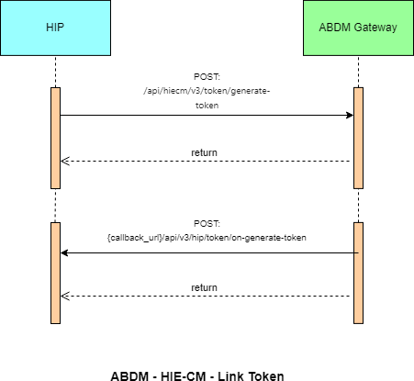
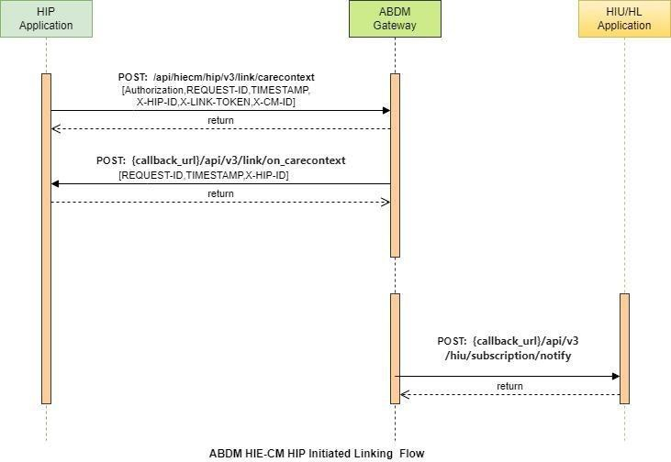

List of APIs

Link token generation

This API invoked by HIP or HRP to generate a link token. URL: /api/hiecm/v3/token/generate-token Method: POST Request Headers:

Property  Name | Example Value | Required | Description
REQUEST-ID | 18235d89-cb13-479d-ad71-  7a57d5f669a8 | Yes | Unique UUID for tracking the end-toend request  transaction
TIMESTAMP | 2022-10-06T10:10:00.587Z | Yes | The actual time when the request was initiated, ISO Date time format represents the date and time
Authorization | eyJhbGciOiJSUzUxMiJ9.  eyJzdWIiOiJ2YXNhbnRoYWt1bWFyLmtlc2F2 YW5Ac2J4IiwiY2xpZW50SWQiOiJz YngiLCJzeXN0ZW0iOiJBQkhBLUEiLCJy  ZXF1ZXN0ZXJJZCI6IlBIUi1XRUIiL  CJwaHJNb2JpbGUiOm51bGwsImV4c CI6MTY2NzI5ODExNSwia  WF0IjoxNjY3MjkwOTE1LCJwaHJBZ  GRyZXNzIjoidmFzYW50aGFrdW1hci5rZX NhdmFuQHNieCIsInR4bklkIjoi  YjEwMGM4ZDMtNTE1ZC00YWFiLTg1O  WQtYzNlMTUwOTE3ZGY1In0 | Yes | JWT Access token which was issued by ABDM session API after successful validation of client id and secret
X-HIP-ID | IN2810014366 | Yes | Identifier of the health information provider to which the request was intended
X-CM-ID | sbx | Yes | Suffix of the consent manager to which the request was intended

Body Parameters:

Property Name | Example Value | Required | Description

abhaAddress | “ABHA address” | Yes (if ABHA number is not provided) | Patient ABHA address against which the health records need to be linked.
abhaNumber | ABHA number | Yes (if ABHA address is not provided) | 14-digit unique ABHA number of the patient.
Name | “Full name” | Yes | Patient's full name in the following format First Name | Middle Name | Last Name
Gender | “M”/”F”/”O” | Yes | Patient gender
yearOfBirth | XXXX | Yes | Patient's year of birth

Request Body:

Request Body
{
"abhaNumber": 98765432101XXXX, "abhaAddress": "user@sbx",
"name": "Arjun",
"gender": "M",
"yearOfBirth": XXXX
}

Response Body:

Response:
Code : 202 Accepted

Error scenarios:
Scenario | Request Headers/Body | Message
When Request ID is Blank, null or empty in header | [  {  "key": "REQUEST-ID",  "value": "",  "type": "text"  }  ] | Access Denied  Code : 403 Forbidden

When invalid Request-ID is pass in header | [  {  "key": "REQUEST-ID",  "value": "{{$guid}}zxzzxs", "type": "text"  }  ] | {  "code": "ABDM-1030: ",  "message": "Invalid request ID"  }  Code: 400Bad Request

When Timestamp is Blank, null or empty in header. | [  ] | {  } | "key": "TIMESTAMP",  "value": "",  "type": "text" | Access Denied  Code : 403 Forbidden
When invalid  Timestamp is pass in header | [  {  "key": "TIMESTAMP",  "value": "{{$isoTimestamp}}jh gftytgtyu",  "type": "text"  }  ] |  |  | {  "code": "ABDM-1016: ",  "message": "Invalid Timestamp"  }  Code - 400Bad Request
When X-HIP-ID is Blank, null or empty in header. | [  ] | {  } | "key": "X-HIP-ID",  "value": "",  "type": "text" | Access Denied  Code : 403 Forbidden
When X-CM-ID is  Invalid, Blank, null or empty in header. | [  ] | {  } | "key": "X-CM-ID",  "value": "sbxdvdfvdf", "type": "text" | Access Denied  Code : 403 Forbidden
Request body missing |  |  |  | {  "code": "ABDM-1064",  "message": "Request body was missi ng"  }  Code : 400Bad Request
Duplicate Link token request | {  "abhaNumber": 9117838618XXXX, "abhaAddress": "9117838610XXXX  @sbx",  "name": "Mayur Chaskar", "gender": "M",  "yearOfBirth": XXXX |  |  | {  "code": "ABDM-1092",  "message": "Duplicate Link token req uest"  }  Code : 400Bad Request

}

ABHA number and ABHA address cannot be null | {  "abhaNumber": null, "abhaAddress": null, "name": "Mayur Bapu",  "gender": "M",  "yearOfBirth": XXXX } | {  "code": "ABDM-1125",  "message": "ABHA number and ABH A address cannot be null"  }  Code - 400Bad Request
When passing an abha number of more or less than 14 digits | {  "abhaNumber": 911783861017XXX, "abhaAddress": "91178386101731X  XXX@sbx",  "name": "Mayur M ",  "gender": "M",  "yearOfBirth": XXXX } | [  {  "code": "ABDM-9999: ",  "message": "Invalid ABHA Number, it must be only 14 digit"  }  ]  Code - 400Bad Request
When passing invalid abha address/Invalid domain. | {  "abhaNumber": 91178386109XXXX  ,  "abhaAddress": "9117838610XXX@ gmail.com",  "name": "Mayur M",  "gender": "M",  "yearOfBirth": 1994 } | [  {  "code": "ABDM-9999: ",  "message": "Invalid ABHA Address, it must start with Alphanumeric . and _ in the middle and must be ending  with @abdm or @sbx"  }  ]  Code - 400Bad Request
When passing invalid Name | {  "abhaNumber": 9117838610XXXX, "abhaAddress": "911783861XXXX@ sbx",  "name": "Mferr",  "gender": "M",  "yearOfBirth": 1994  } | Callback: { "error": {  "code": "ABDM-1207: ",  "message": "Demographic details was invalid or doesn't exists"  },  "response": {  "requestId": "58f080de-b5444bcf-8f4b-3d45222b2885"  }  }  Code- 202Accepted

When passing invalid  Gender except M, F, O, D | {  "abhaNumber": 9117838610XXXX, "abhaAddress": "9117838610XXXX  @sbx",  "name": "Mayur B ",  "gender": "W",  "yearOfBirth": XXXX } | [  {  "code": "ABDM-9999: ",  "message": "Invalid Gender, It mus t be M, F, O, D"  }  ]  Code- 400Bad Request
Year Of Birth should be in between 1900 to 2200. | {  "abhaNumber": 9117838610XXX, "abhaAddress": "9117838610XXX@ sbx",  "name": "Mayur B",  "gender": "M",  "yearOfBirth": XX  } | [  {  "code": "ABDM-9999: ",  "message": "Invalid Year of birth, must be 4 digit range between 1900 a nd 2200"  }  ]  Code- 400Bad Request
When passing F, O, D gender for male. | {  "abhaNumber": 9117838610XXXX, "abhaAddress": "9117838610XXXX  @sbx",  "name": "Mayur B ",  "gender": "F",  "yearOfBirth": XXXX } | Callback: { "error": {  "code": "ABDM-1207: ",  "message": "Demographic details was invalid or doesn't exists"  },  "response": {  "requestId": "89d2dcb4-06a545fa-8910-417d6e83bdd5"  }  }  Code- 202Accepted
When Year of birth not matching with user’s YearOfBirth.  (Allowing +2 & -2 from original year) | {  "abhaNumber": 9117838610XXXX, "abhaAddress": "9117838610XXXX  @sbx",  "name": "Mayur B",  "gender": "M",  "yearOfBirth": XXXX } | Callback: { "error": {  "code": "ABDM-1207: ",  "message": "Demographic details was invalid or doesn't exists"  },  "response": {  "requestId": "58f080de-b5444bcf-8f4b-3d45222b2885"  }  }  Code- 202Accepted
When abha numbe  r is passing of another’s user. | {  "abhaNumber": 9117838610XXXX, "abhaAddress": "9117838610XXXX  @sbx", | Callback: { "error": {  "code": "ABDM-1207: ",

 | "name": "Mayur B ",  "gender": "F",  "yearOfBirth": XXXX } | "message": "Demographic details was invalid or doesn't exists"  },  "response": {  "requestId": "58f080de-b5444bcf-8f4b-3d45222b2885"  }  }  Code- 202Accepted
When abha Address is passing of another’s user. | {  "abhaNumber": 9117838610XXXX, "abhaAddress": "9117838610XXXX  @sbx",  "name": "Mayur B",  "gender": "F",  "yearOfBirth": XXXX  } | Callback: { "error": {  "code": "ABDM-1207: ",  "message": "Demographic details was invalid or doesn't exists"  },  "response": {  "requestId": "89d2dcb4-06a545fa-8910-417d6e83bdd5"  }  }  Code- 202Accepted
When the user tries to generate a link token more than 3 times | {  "abhaNumber": 9117838610XXXX, "abhaAddress": "9117838610XXXX  @sbx",  "name": "Mayur B",  "gender": "M",  "yearOfBirth": XXXX  } | Callback: {  "abhaAddress": "91178386101731@sbx  ",  "error": {  "code": "ABDM-1027: ",  "message": "You are blocked. Plea se try again after 24 hours."  },  "response": {  "requestId": "ddcd6213-49e24d46-ad44-07897c63c36b"  }  }

Callback API for Link token generation

This is a callback API triggered by HIE-CM to HIP/HRP to get the link token.
URL: {callback_url}/api/v3/hip/token/on-generate-token
Method: POST

Request Headers:

Property  Name | Example Value | Required | Description
REQUEST-ID | 18235d89-cb13-479d-ad71-  7a57d5f669a8 | Yes | Unique UUID for tracking the end-toend request  transaction.
TIMESTAMP | 2022-10-06T10:10:00.587Z | Yes | The actual time when the request was initiated, ISO Date time format represents the date and time
X-HIP-ID | IN2810014366 | Yes | Identifier of the health information provider to which the request was intended.
Authorization | eyJhbGciOiJSUzUxMiJ9.  eyJzdWIiOiJ2YXNhbnRoYWt1bWFyLmtlc2F2 YW5Ac2J4IiwiY2xpZW50SWQiOiJz YngiLCJzeXN0ZW0iOiJBQkhBLUEiLCJy  ZXF1ZXN0ZXJJZCI6IlBIUi1XRUIiL  CJwaHJNb2JpbGUiOm51bGwsImV4c CI6MTY2NzI5ODExNSwia  WF0IjoxNjY3MjkwOTE1LCJwaHJBZ  GRyZXNzIjoidmFzYW50aGFrdW1hci5rZX NhdmFuQHNieCIsInR4bklkIjoi  YjEwMGM4ZDMtNTE1ZC00YWFiLTg1O  WQtYzNlMTUwOTE3ZGY1In0 | Yes | JWT Access token which was issued by ABDM session API after successful validation of client id and secret

Body parameters:

Property  Name | Example Value | Required | Description
abhaAddress | ABHA address | Yes (if ABHA number is not provided) | Patient ABHA address against which the health records need to be linked
linkToken | eyJhbGciOiJSUzUxMiJ9.eyJoaXBJZCI6Ik1BRE hVUkFfSElQIiwic3ViIjoiMTAwMDAyNjIxMzE2N DBAYWJkbSIsImFiaGFOdW1iZXIiOjEwMDAwM jYyMTMxNjQwLCJleHAiOjE2OTc1OTY2MDAsI mlhdCI6MTY4MTgyODYwMCwidHJhbnNhY3 Rpb25JZCI6IjM1YjkzYzQwLWM1OGQtNDk2ZC  04MDgxLWY1OTM0MWVkNGNkNSIsImFiaGFB | Yes | Patient full name: First Name |  Middle Name | Last Name

ZGRyZXNzIjoiMTAwMDAyNjIxMzE2NDBAYWJk bSJ9.q-p8eHxdacvSg2QPzm7vY7_kLHYCQXwkbkAc EvSwcp5HFAdtUyNoZ50LyquQih2Lbxv0Dxm Da3YxyMnQY37GJsBpcs-
4OQmUk5tvoad1HYGjBVMlq0tVae7gpFHno nSSyhkVPGLTO5G4tvghvcK8xcMqoQol_lmR
26VIGCue07nx6K4xPueUOQeeqKMXPJs115wPunafT3LT24 k9KEHzbmDcWDJjUouBZ4TKAXcGrfwOuhG
M0eWr-
SMZ99PAlTHxHCZnJybUWL9E2MH6bpq87wD
hFPrq0WLzhLJhynnfaWxrd7JkFdUtDygkpaiR h3V12xVqx8eWaSwxdwvCLut4A
requestId | d6d6d056-666a-4af8-b6804c61bcb29dd4 | Yes | Unique UUID to track the endto-end flow

Request Body:

Request Body
{
"abhaAddress": "10000262131640@sbx",
"linkToken": "eyJhbGciOiJSUzUxMiJ9.eyJoaXBJZCI6Ik1BREhVUkFfSElQIiwic3ViIjoiMTAwMDAyNjIxMzE2 NDBAYWJkbSIsImFiaGFOdW1iZXIiOjEwMDAwMjYyMTMxNjQwLCJleHAiOjE2OTc1OTY2MDAsImlhdCI6MT Y4MTgyODYwMCwidHJhbnNhY3Rpb25JZCI6IjM1YjkzYzQwLWM1OGQtNDk2ZC04MDgxLWY1OTM0MWV
kNGNkNSIsImFiaGFBZGRyZXNzIjoiMTAwMDAyNjIxMzE2NDBAYWJkbSJ9.q-
p8eHxdacvSg2QPzm7vY7_kLHYCQXwkbkAcEvSwcp5HFAdtUyNoZ50LyquQih2Lbxv0DxmDa3YxyMnQ Y37GJsBpcs-4OQmUk5tvoad1HYGjBVMlq0tVae7gpFHnonSSyhkVPGLTO5G4tvghvcK8xcMqoQol_lmR26VIGCue07
-
nx6K4xPueUOQeeqKMXPJs115wPunafT3LT24k9KEHzbmDcWDJjUouBZ4TKAXcGrfwOuhGM0eWrSMZ99PAlTHxHCZnJybUWL 9E2MH6bpq87wDhFPrq0WLzhLJhynnfaWxrd7JkFdUtDygkpaiRh3V12xVqx8 eWaSwxdwvCLut4A",
"response": {
"requestId": "d6d6d056-666a-4af8-b680-4c61bcb29dd4"
}
}

Response Body

Response
Code : 202 Accepted

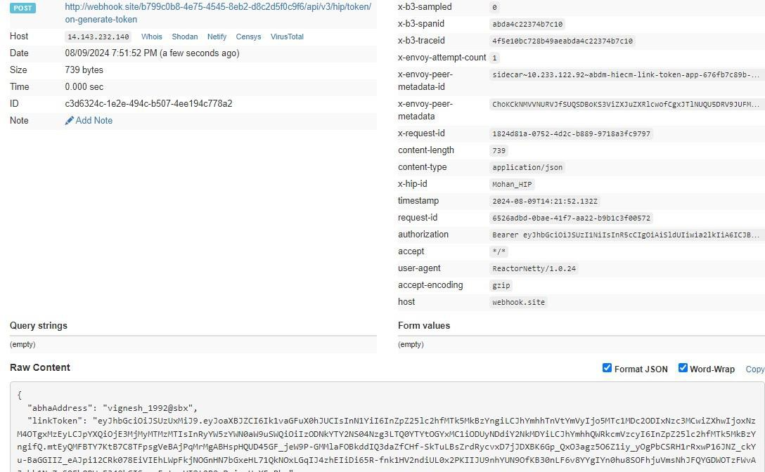

Error Scenarios:
Scenario | Headers/Body |  |  | Message
When Request ID is Blank, null or empty in header | [  ] | {  } | "key": "REQUEST-ID",  "value": "",  "type": "text" | Access Denied  Code : 403 Forbidden
When invalid Request-ID is pass in header | [  ] | {  } | "key": "REQUEST-ID",  "value": "{{$guid}}zxzzxs", "type": "text" | {  "code": "ABDM-1030: ",  "message": "Invalid request ID"  }  Code: 400Bad Request
When Timestamp  is Blank, null or empty in header. | [  ] | {  } | "key": "TIMESTAMP",  "value": "",  "type": "text" | Access Denied  Code : 403 Forbidden

When invalid  Timestamp is pass in header | [  {  "key": "TIMESTAMP", | {  "code": "ABDM-1016: ",  "message": "Invalid Timestamp"  }

 | "value": "{{$isoTimestamp}}jhgftyt gtyu", |  |  | Code - 400Bad Request
 | "type": "text"
 |  | }
 | ]
When X-HIP-ID is Blank, null or empty in header. | [  ] | {  } | "key": "X-HIP-ID",  "value": "",  "type": "text" | Access Denied  Code : 403 Forbidden
When X-CM-ID is Invalid, Blank, null, or empty in the header. | [  ] | {  } | "key": "X-CM-ID",  "value": "sbxdvdfvdf", "type": "text" | Access Denied  Code : 403 Forbidden
When X-LINKTOKEN is  Blank, null, or empty in the header. | [  ] | {  } | "key": "X-LINK-TOKEN",  "value": "",  "type": "text" | Access Denied  Code : 403 Forbidden
 | [ | {  } |  | {  "code": "ABDM-1066: ",  "message": "Invalid JWT token"  }  Code - 400Bad Request
When X-LINK-  TOKEN is Invalid in the header. | ", | {  } | "key": "X-LINK-TOKEN",  "value": "hghhjjkhjkbkjbjkbkjbnkjbk  "type": "text"
 | ] | {  }

When the HIP ID is not matching with Link Token in Header | [  {  "key": "X-HIP-ID",  "value": "XYZ",  "type": "text"  },  {  "key": "X-LINK-TOKEN",  "value": "eyJhbGciOiJSUzUYr9LtA5  A",  "type": "text"  } | {  "code": "ABDM-1063",  "message": "HIP Id mismatch with Link token"  }  Code - 400Bad Request

 | ]
When passing the Link Token of another user in the header | [  {  "key": "X-LINK-TOKEN",  "value": "eyJhbGciOiJSUzUxMiJ9.ey JoaXBJZCI6IlN1YzTlcJDFRfSAhPZxRpAr mlevBdVt4rLk-  EkCRGfLmFqizijYO7z_pdasi35fG6dknrNDQb1vf-0o0ggQHOyjhD2aJLBDGjSKsAOidU9qS  usEjBC6j4HU3uZjyFPMQjg", "type": "text"  }  ] | {  "code": "ABDM-1038",  "message": "ABHA address misma tch with Link token"  }  Code : 400Bad Request
Request body missing |  | {  "code": "ABDM-1064",  "message": "Request body was mi ssing"  }  Code : 400Bad Request

Duplicate HIP Link request | {  "abhaNumber": "91178386101731", "abhaAddress": "91178386101731@sbx"  ,  "patient": [  {  "referenceNumber": "Mayur C", "display": "Apollo_Encounter_123  _2023070414",  "careContexts": [  {  "referenceNumber": "Health Document Reference Number",  "display": "Sugar Test"  }  ],  "hiType": "PRESCRIPTION",  "count": 1  }  ]  } | {  "code": "ABDM-1090",  "message": "Duplicate HIP link req uest"  }
When Abha Number is mismatch with Link Token | {  "abhaNumber": "11111111111111", "abhaAddress": "91178386101731@sbx"  ,  "patient": [  {  "referenceNumber": "Mayur C", | {  "code": "ABDM-1062",  "message": "ABHA number misma tch with Link token"  }

"display": "Apollo_Encounter_123
_2023070414",
"careContexts": [
{
"referenceNumber": "Health Document Reference Number",
"display": "Sugar Test"
}
],
"hiType": "PRESCRIPTION",
"count": 1
}
]
}

When Abha Number | { |  |  | {
is mismatch with | "abhaNumber": "91178386101731", |  |  | "code": "ABDM-1038",
Link Token | "abhaAddress": "11111111111111@sbx", |  |  | "message": "ABHA address misma
 | "patient": [ |  |  | tch with Link token"
 | { |  |  | }
 | "referenceNumber": "Mayur C",
 | "display": "Apollo_Encounter_123
 | _2023070414", |  |  | Code - 400Bad Request
 | "careContexts": [
 | {
 | "referenceNumber": "Health
 | Document Reference Number",
 | "display": "Sugar Test"
 | }
 | ],
 | "hiType": "PRESCRIPTION",
 | "count": 1
 | }
 | ]
 | }
If care context is null | {  "abhaNumber": "91178386101731", "abhaAddress": "91178386101731@sbx"  ,  "patient": [  {  "referenceNumber": "Mayur C", "display": "Apollo_Encounter_123  _2023070414",  "careContexts": null, "hiType": "PRESCRIPTION",  "count": 1 |  |  | [  {  "code": "ABDM-9999: ",  "message": "careContexts attrib ute required in the payload"  }  ]  Code - 400Bad Request
 |  |  | }
 |  | ]
 | }

when passing invlalid HiType | {  "abhaNumber": "9117838610XXXX ", "abhaAddress": "9117838610XXXX  @sbx",  "patient": [  {  "referenceNumber": "Mayur C", "display": "Apollo_Encounter_123  _2023070414",  "careContexts": [  {  "referenceNumber": "Health Document Reference Number",  "display": "Sugar Test"  }  ],  "hiType": "PRESCRsbjs", "count": 1  }  ]  } | [  {  "code": "ABDM-9999: ",  "message": "Invalid HIType, it m ust be in PRESCRIPTION, DIAGNOSTIC REPORT, OPCONSULTATION, DISCHAR  GESUMMARY, IMMUNIZATIONRECORD, HEALTHDOCUMENTRECORD, WELLNE SSRECORD"  }  ]  Code - 400Bad Request
If count is not matching with Care Context count | {  "abhaNumber": "91178386101731", "abhaAddress": "91178386101731@sbx"  ,  "patient": [  {  "referenceNumber": "Mayur C", "display": "Apollo_Encounter_123  _2023070414",  "careContexts": [  {  "referenceNumber": "Health Document Reference Number",  "display": "Sugar Test"  }  ],  "hiType": "PRESCRIPTION",  "count": 20  }  ]  } | Callback: {  "abhaAddress": "91178386101731@s bx",  "error": {  "code": "ABDM-1037: ",  "message": "Count and Care co ntext count mismatch"  },  "response": {  "requestId": "ab00fdec-fc804502-b1bc-121be6808a9f"  }  }  Code - 202Accepted

Linking care context
This API needs to be called by the HIP to link the care context against the patient ABHA address, once the HIP has the valid linking token generated against the same patient ABHA address.

URL: /api/hiecm/hip/v3/link/carecontext Request: POST
Header Parameters:
Property  Name | Example Value | Require d | Descriptio n
REQUEST-ID | 18235d89-cb13-479d-ad71-7a57d5f669a8 | Yes | Unique UUID for  tracking the endto-end request  transaction.
TIMESTAMP | 2022-10-06T10:10:00.587Z | Yes | The actual time when the request was initiated, ISO Date time format represents date and  time.
Authorizati on | eyJhbGciOiJSUzUxMiJ9.eyJzdWIiOiJ2YXNhbnRo YWt1bWFyLmtlc2F2YW5Ac2J4IiwiY2xpZW50SW  QiOiJzYngiLCJzeXN0ZW0iOiJBQkhBLUEiLCJyZXF 1ZXN0ZXJJZCI6IlBIUi1XRUIiLCJwaHJNb2JpbGUiO  m51bGwsImV4cCI6MTY2NzI5ODExNSwiaWF0Ijo xNjY3MjkwOTE1LCJwaHJBZGRyZXNzIjoidmFzYW 50aGFrdW1hci5rZXNhdmFuQHNieCIsInR4bklkIjo  iYjEwMGM4ZDMtNTE1ZC00YWFiLTg1OWQtYzNlM TUwOTE3ZGY1In0 | Yes | JWT Access token which was issued  by ABDM session API after successful validation of client id and  secret.
X-HIP-ID | IN2810014366 | Yes | Identifier of the health information provider to which the request was  intended.
X-CM-ID | sbx | Yes | Suffix of the consent manager to  which the  request was  intended.
X-LINK-TOKEN | “eyJhbGciOiJSUzUxMiJ9.eyJoaXBJZCI6Ik1BREhV UkFfREVNTyIsInN1YiI6InBhcmFnQHNieCIsImFiaG FOdW1iZXIiOjcxMTYyODUwMTMzNjYzLCJleHAiOj E2OTA5MTIzMDEsImlhdCI6MTY3NTE0NDMwMS  widHJhbnNhY3Rpb25JZCI6IjhjMjYyZTFhLTlhY2M tNDM1YS04OTY4LTVlODY1YjUzNjQwNSIsImFiaGF  BZGRyZXNzIjoicGFyYWdAc2J4In0.aNDRjI- | Yes | Link token generated against patient ABHA  address and/or ABHA  number.

WKUecEX7BAM710B1aFkHfhB5nB-
ND4T3Lpm9kFCNJlj9BVLUaLZAMU0svscEMrPuZXONG1
JalymEjhlCYvjBsFOSBUQ5CTFdoT4VDJC3P2u2X 3Xhi5tepTZrgsYMafuhMRXvRfqSjn0kSLJQloAr5fi NQdBWWMGsYwcFLWLjo4MSwHC6AS9RMUfY3
w4_J4qy4zgqULBoedITc1tQHxDlIg7amvXXgYzn
29Iam65cQG0sseRYf_ceI5kq3mxn154Lpwzh_lH_VXOx0h9MDvLFf76TXgozce8_Q8 SKEsyB1U pbes2vQ59qjQS4e9MHbtRHeyEeJ2IMmThYQ”
Body Parameters:
Property Name | Example Value | Required | Description
abhaAddress | ABHA address | Yes | Patient ABHA address against which the health records need to be linked. ABHA address is mandatory.
abhaNumber | ABHA number | No | 14-digit unique ABHA number of the patient.
referenceNumber | “TMH-PUID-001” | Yes | This should be a unique ID or number for each new response.
display | “Display” | Yes | Displayed information about the care contexts
careContexts | "careContexts": [  {  "referenceNumber": "TMH-PUID", "display": "display 1"  }  ] | Yes | Care context is the patient individual health record.
hiType | “PRESCRIPTION” | Yes | There are 7 different hiTypes in ABDM:  Prescription  DiagnosticReport OPConsultation  DischargeSummary  ImmunizationRecord HealthDocumentRecord  WellnessRecord
count | 1 | Yes | Number of health records in the careContext object
Request Body:
Request Body
{
"abhaNumber": 9117838610XXXX, "abhaAddress": "abc@abdm",

"patient": [
{
"referenceNumber": "TMH-PUID-001", "display": "Display",
"careContexts": [
{
"referenceNumber": "TMH-PUID-001", "display": "display 1"
}
],
"hiType": "PRESCRIPTION",
"count": 1
}
] }

Response Body:
Response
Code : 202 Accepted

Error scenarios:

Scenario | Headers/Body | Message
When the Request ID is Blank, null, or empty in the  header | [{"key":"REQUEST-  ID","value":"","type":"text"}] | Access Denied
When the Request ID is Blank, null, or empty in the  header | [{"key":"REQUEST-  ID","value":"","type":"text"}] | Code : 403 Forbidden
When an invalid Request ID is passed in the header | [{"key":"REQUEST-  ID","value":"{{$guid}}zxzzxs"," type":"text"}] | {
When an invalid Request ID is passed in the header |  | "code": "ABDM-1030: ",
When an invalid Request ID is passed in the header |  | "message": "Invalid request  ID"
When an invalid Request ID is passed in the header |  | }
When an invalid Request ID is passed in the header |  | Code: 400Bad Request
When Timestamp is Blank, null, or empty in the header. | [{"key":"TIMESTAMP","value":"",  "type":"text"}] | Access Denied
When Timestamp is Blank, null, or empty in the header. | [{"key":"TIMESTAMP","value":"",  "type":"text"}] | Code : 403 Forbidden
When an invalid  Timestamp is passed in the header | [{"key":"TIMESTAMP","value":"{  {$isoTimestamp}}jhgftytgty u","type":"text"}] | {
When an invalid  Timestamp is passed in the header |  | "code": "ABDM-1016: ",
When an invalid  Timestamp is passed in the header |  | "message": "Invalid Timestamp"
When an invalid  Timestamp is passed in the header |  | }
When an invalid  Timestamp is passed in the header |  | Code - 400Bad Request

Access Denied

When X-HIP-ID is Blank, null, or empty in the header. | [{"key":"X-HIP-  ID","value":"","type":"text"}] | Code : 403 Forbidden
When X-CM-ID is Invalid, Blank, null or empty in header. | [{"key":"X-CM-  ID","value":"sbxdvdfvdf","type ":"text"}] | Access Denied
When X-CM-ID is Invalid, Blank, null or empty in header. | [{"key":"X-CM-  ID","value":"sbxdvdfvdf","type ":"text"}] | Code : 403 Forbidden
When X-LINK-TOKEN is Blank, null or empty in header. | [{"key":"X-LINK-  TOKEN","value":"","type":"text"}  ] | Access Denied
When X-LINK-TOKEN is Blank, null or empty in header. | [{"key":"X-LINK-  TOKEN","value":"","type":"text"}  ] | Code : 403 Forbidden
When X-LINK-TOKEN is Invalid in header. | [{"key":"X-LINK-  TOKEN","value":"hghhjjkhjkbkj bjkbkjbnkjbk","type":"text"}] | {
When X-LINK-TOKEN is Invalid in header. |  | "code": "ABDM-1066: ",
When X-LINK-TOKEN is Invalid in header. |  | "message": "Invalid JWT token"
When X-LINK-TOKEN is Invalid in header. |  | }
When X-LINK-TOKEN is Invalid in header. |  | Code - 400Bad Request
When HIP ID is not matching with Link Token in Header | [{"key":"X-HIP-  ID","value":"XYZ","type":"text"},  {"key":"X-LINK-  TOKEN","value":"eyJhbGciOiJ SUzUYr9LtA5A","type":"text"}] | {
When HIP ID is not matching with Link Token in Header |  | "code": "ABDM-1063",
When HIP ID is not matching with Link Token in Header |  | "message": "HIP Id mismatch with Link token"
When HIP ID is not matching with Link Token in Header |  | }
When HIP ID is not matching with Link Token in Header |  | Code - 400Bad Request

 | [{"key":"X-LINK-
 | TOKEN","value":"eyJhbGciOiJ
 | SUzUxMiJ9.eyJoaXBJZCI6IlN1
 | Yl9ISVAiLCJzdWIiOiI5MTQxN
 | DA3MTMyMTgyNUBhYmRtIi
 | wiYWJoYU51bWJlciI6OTE0M
 | TQwNzEzMjE4MjUsImV4cCI6
 | MTY5OTI5ODE2NCwiaWF0Ijo
 | xNjgzNTMwMTY0LCJ0cmFuc
 | 2FjdGlvbklkIjoiZTI5YTA3ZDkt
 | YTA0OC00N2NhLWI1MTUtNT  kyMjMwMDk5NmVjIiwiYWJo YUFkZHJlc3MiOiI5MTQxNDA3 |  | {  "code": "ABDM-1038",  "message": "ABHA address
When passing Link Token of another user in header | MTMyMTgyNUBhYmRtIn0.IZq  QAtFNBnEav0nT4XSG3XDDX KDTljAMPYW-I81EU9xkhi-  9xK6MrzTw5xlzaOasllcJDFRf |  | mismatch with Link token"  }
 | SAhPZxRpArmlevBdVt4rLkEkCRGfLmFqizijYO7z_pdasi3  5-fG6bV3DbCidO8ZM2zl_wHi5vDXZbv3gJvjBQ4Hd0 |  | Code : 400Bad Request
 | Pz62WRJSbcRt62Dfcha3HYr1
 | gKcKZCkojDk94RGNYWevdH
 | KYgr4lFdu_EKuuykyFlk5VjBe
 | oLFyivpqjiQmbPeRutE_T7B9
 | G4VveakeyAQosLHAG6dknrNDQb1vf-
0o0ggQHOyjhD2aJLBDGjSK
sAOidU9qSusEjBC6j4HU3uZj yFPMQjg","type":"text"}]
Request body missing |  |  | {
Request body missing |  |  | "code": "ABDM-1064",
Request body missing |  |  | "message": "Request body was missing"
Request body missing |  |  | }
Request body missing |  |  | Code : 400Bad Request
Duplicate HIP Link request | {  "abhaNumber": "9117838610XXXX ", "9117838610XXXX @sbx",  "patient": [  {  "referenceNumber": "Mayur C", | "abhaAddress": | {  "code": "ABDM-1090",  "message": "Duplicate HIP link request"  }

"display":
"Apollo_Encounter_123_20230 70414",
"careContexts": [
{
"referenceNumber": "Health Document Reference Number",
"display": "Sugar
Test"
}
],
"hiType": "PRESCRIPTION",
"count": 1
}
]
}
When Abha Number is mismatch with Link Token | {  "abhaNumber": "11111111111111",  "abhaAddress": "91178386101731@sbx",  "patient": [  {  "referenceNumber": "Mayur C",  "display":  "Apollo_Encounter_123_20230 70414",  "careContexts": [  {  "referenceNumber": "Health Document Reference Number",  "display": "Sugar  Test"  }  ],  "hiType": "PRESCRIPTION",  "count": 1  }  ]  } | {  "code": "ABDM-1062",  "message": "ABHA number mismatch with Link token"  }

 | {
Empty patient details in the request | {  "abhaNumber": 12345678901  234,  "abhaAddress": "abc@abdm"  ,  "patient": []  } | {  "code": "ABDM-1115",  "message": "Invalid patient information. At least one patient information is required."  }
Trying to link a record for a deleted abha address | {  "abhaNumber": "91178386101731",  "abhaAddress": "91178386101731@sbx",  "patient": [  {  "referenceNumber": "Mayur C",  "display": "Apollo_Encounter_123_20230 70414",  "careContexts": [  {  "referenceNumber": "Health Document Reference Number",  "display": "Sugar  Test"  }  ],  "hiType": "PRESCRIPTION",  "count": 1  }  ]  } | {  "code": "ABDM-1031", "message": "The abha  address is deactivated."  }

Call back API for linking care context with patient ABHA address

This is a callback API triggered by HIE-CM to notify HIP/HRP about linked care context response.
URL: {callback_url}/api/v3/link/on_carecontext
Request: POST

Header Parameters:
Property  Name | Example Value | Required | Description

REQUEST-ID | 18235d89-cb13-479d-ad71-  7a57d5f669a8 | Yes | Unique UUID for tracking the end-toend request  transaction.
TIMESTAMP | 2022-10-06T10:10:00.587Z | Yes | The actual time when the request was initiated, ISO 8601 represents the date and time by starting with the year, followed by the month, the day, the hour, the minutes, seconds, and milliseconds.
X-HIP-ID | IN2810014366 | Yes | Identifier of the health information provider to which the request was intended.
Authorization | eyJhbGciOiJSUzUxMiJ9.  eyJzdWIiOiJ2YXNhbnRoYWt1bWFyLmtlc2F2 YW5Ac2J4IiwiY2xpZW50SWQiOiJz YngiLCJzeXN0ZW0iOiJBQkhBLUEiLCJy  ZXF1ZXN0ZXJJZCI6IlBIUi1XRUIiL  CJwaHJNb2JpbGUiOm51bGwsImV4c CI6MTY2NzI5ODExNSwia  WF0IjoxNjY3MjkwOTE1LCJwaHJBZ  GRyZXNzIjoidmFzYW50aGFrdW1hci5rZX NhdmFuQHNieCIsInR4bklkIjoi  YjEwMGM4ZDMtNTE1ZC00YWFiLTg1O  WQtYzNlMTUwOTE3ZGY1In0 | Yes | JWT Access token which was issued by ABDM session API after successful validation of client id and secret

Body Parameters:
Property  Name | Example Value | Required | Description
abhaAddress | "abc@abdm" | Yes | Patient ABHA address against which the health records need to be linked

status | "Successfully Linked care context" | Yes | Status message in various scenarios: "Successfully Linked care context" “Counter and Care context count mismatch”  “ABHA address and Link token mismatch” “Dependent service unavailable” “These care contexts have been already linked"
requestId | “f29f0e59-8388-  4698-9fe605db67aeac46” | Yes | Unique UUID for tracking the endto-end request transaction.
Request Body:
Request Body
{
"abhaAddress": "abc@sbx",
"status": "Successfully Linked care context", "response": {
"requestId": "f29f0e59-8388-4698-9fe6-05db67aeac46"
}
}
Error Scenario:
{
"error": {
"code": "ABDM-1056",
"message": "This care context has been already linked"
},
"response": {
"requestId": "5ad6e060-ea35-4765-8c8c-cd7db8cb1a6f"
}}
Response Body:
Response
Code : 202 Accepted

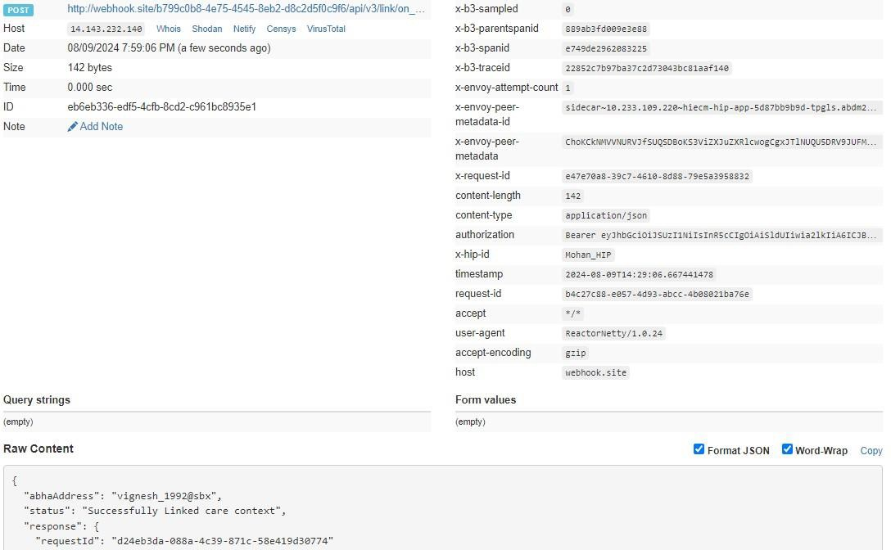

Call back HIU
All the HIUs who are subscribed will be notified about the linkage of care contexts.

Get all patient links

This API provide all the linked care context of the patient.
URL: /api/hiecm/hip/v3/link/patient/links Request: GET

Header Parameters:
Property  Name | Example Value | Required | Description

Authorization | eyJhbGciOiJSUzUxMiJ9. eyJzdWIiOiJ2 YXNhbnRoYWt1bWFyLmtlc2F2  YW5Ac2J4IiwiY2xpZW50SWQiOiJzYngi LCJzeXN0ZW0iOiJBQkhBLUEiLCJy  ZXF1ZXN0ZXJJZCI6IlBIUi1XRUIiLCJwaHJ  Nb2JpbGUiOm51bGwsImV4c  CI6MTY2NzI5ODExNSwiaWF0IjoxNjY3Mj kwOTE1LCJwaHJBZ  GRyZXNzIjoidmFzYW50aGFrdW1hci5rZ XNhdmFuQHNieCIsInR4bklkIjoi  YjEwMGM4ZDMtNTE1ZC00YWFiLTg1OW  QtYzNlMTUwOTE3ZGY1In0 | Yes | JWT Access token which was issued by ABDM session API after successful  validation of client id and secret
REQUEST-ID | 18235d89-cb13-479d-ad71-  7a57d5f669a8 | Yes | Unique UUID for tracking the end-to-end request transaction
TIMESTAMP | 2023 -03-09T07:07:41.793Z | Yes | The actual time when the request was initiated, ISO Date time format represents the date and time
X-AUTH-TOKEN | eyJhbGciOiJSUzUxMiJ9.eyJzdWIiOiJ2 YXNhbnRoYWt1bWFyLmtlc2F2 |  | JWT Authentication token which was issued by ABDM after successful  validation of username and password
X-CM-ID | sbx | Yes | Suffix of the consent manager to which the request was intended

Request Params:

Property Name | Example Value | Description
limit | 100 | Number of records to be fetched from the database.
Error scenarios:

Scenarios | Headers/Body |  |  | Message
To verify when | [ |  |  | Access Denied
Request ID is Blank, |  | { |  | Code : 403 Forbidden
null or empty in |  |  | "key": "REQUEST-ID",
header |  |  | "value": "",
 |  |  | "type": "text"
 |  | }
 | ]
 | [ |  |  | {

To verify when  invalid RequestID is pass in header | ] | {  } | "key": "REQUEST-ID",  "value": "{{$guid}}zxzzxs", "type": "text" | "code": "ABDM-1030: ",  "message": "Invalid reque st ID"  }  Code: 400Bad Request
When | [ |  |  | Access Denied
Timestamp is |  | { |  | Code : 403 Forbidden
Blank, null or empty |  |  | "key": "TIMESTAMP",
in header. |  |  | "value": "",
 |  |  | "type": "text"
 |  | }
 | ]
When invalid | [  ] | {  } | "key": "TIMESTAMP",  "value": "{{$isoTimestamp}}jhgftytgtyu", "type": "text" | {
Timestamp is pass | [  ] | {  } |  | "code": "ABDM-1016: ",
in header | [  ] | {  } |  | "message": "Invalid Times
 | [  ] | {  } |  | tamp"
 | [  ] | {  } |  | }
 | [  ] | {  } |  | Code - 400Bad Request
 | [  ] | {  } |  | Access Denied
 | [  ] | {  } |  | Code : 403 Forbidden
When X-CM-ID | [ |  |  | Access Denied
is Invalid, Blank, null or empty in header. |  | { | "key": "X-CM-ID", | Code : 403 Forbidden
 |  |  | "value": "sbxdvdfvdf",
 |  |  | "type": "text"
 |  | }
 | ]
When X-Auth-TOKEN is Invalid in header. | [  ] | {  } | "key": "X-AUTH-TOKEN",  "value": "hghhjjkhjkbkjbjkbkjbnkjbk", "type": "text" | {  ""code"": ""ABDM-1065: "",  ""message"": "" Invalid X Auth token""  }  Code - 400Bad Request"

Response Body:

Response
{
"patient": {
"id": "user_1992@sbx", "links": [
{
"hip": {
"id": "TestClinicHIP", "name": "TestClinicHIP", "type": "HIP"
},
"referenceNumber": "user_1992@sbx", "display": "User Record",
"hiType": "HealthDocumentRecord", "careContexts": [
{
"referenceNumber": "e707c945-3672-4b85-8525-4c7e620ef301", "display": "Visited on 08-Feb-2024 09:00:00 Visit Type as Out Patient"
}
],
"dateCreated": "2024-07-18T11:49:15.736Z"
}
]
}
}

Notify care context update

This API will be invoked by HIP after updating a health record to notify all the subscribed HIUs.
URL: /api/hiecm/hip/v3/link/context/notify Request: POST

Header Parameters:
Property  Name | Example Value | Required | Description

Authorization | eyJhbGciOiJSUzUxMiJ9. eyJzdWIiOiJ2 YXNhbnRoYWt1bWFyLmtlc2F2  YW5Ac2J4IiwiY2xpZW50SWQiOiJzYngi LCJzeXN0ZW0iOiJBQkhBLUEiLCJy  ZXF1ZXN0ZXJJZCI6IlBIUi1XRUIiLCJwaHJ  Nb2JpbGUiOm51bGwsImV4c  CI6MTY2NzI5ODExNSwiaWF0IjoxNjY3Mj kwOTE1LCJwaHJBZ  GRyZXNzIjoidmFzYW50aGFrdW1hci5rZ XNhdmFuQHNieCIsInR4bklkIjoi  YjEwMGM4ZDMtNTE1ZC00YWFiLTg1OW QtYzNlMTUwOTE3ZGY1In0 | Yes | JWT Access token which was issued by ABDM session API after successful  validation of client id and secret
REQUEST-ID | 18235d89-cb13-479d-ad71-  7a57d5f669a8 | Yes | Unique UUID for tracking the end-to-end request transaction
TIMESTAMP | 2023 -03-09T07:07:41.793Z | Yes | The actual time when the request was initiated, ISO Date time format represents the date and time
X-HIP-ID | IN2810014366 |  | Identifier of the health information provider to which the request was intended
X-CM-ID | sbx | Yes | Suffix of the consent manager to which the request was intended
Body Parameters:
Property Name | Example Value | Required | Description
Patient | “patient” : {  “id”: “user123@sbx”  } | Yes | The abha address of the patient whose record was updated.
careContext | "careContext": {  "patientReference": "batman@tmh",  "careContextReference": "Episode1"  } | Yes | Updated health record of the patient.

hiTypes | "hiTypes": [ "OPConsultation"  ] | Yes | There are 7 different hiTypes in ABDM: Prescription  DiagnosticReport OPConsultation  DischargeSummary  ImmunizationRecord HealthDocumentRecord WellnessRecord
Date | “2024-05-30T05:21:34.155Z” | Yes | The UTC time when the request was initiated, ISO Date time format represents the date and time.
Hip | "hip": {  "id": "demo-hip-261222"  } | Yes | Identifier of the health information provider.

Request Body:

Request Body:
{
"notification": { "patient": {
"id": "user_122@sbx"
},
"careContext": {
"patientReference": "batman@tmh", "careContextReference": "Episode1"
},
"hiTypes": [ "OPConsultation"
],
"date": "2024-05-30T05:21:34.155Z",
"hip": {
"id": "demo-hip-261222"
}
} }

Error scenarios:

Scenarios | Headers/Body |  |  | Message
To verify when Request ID is Blank, null or empty in  header | [  ] | {  } | "key": "REQUEST-ID",  "value": "",  "type": "text" | Access Denied  Code : 403 Forbidden
To verify when  invalid RequestID is pass in header | [  ] | {  } | "key": "REQUEST-ID",  "value": "{{$guid}}zxzzxs", "type": "text" | {  "code": "ABDM-1030: ",  "message": "Invalid requ est ID"  }  Code: 400Bad Request
When  Timestamp is  Blank, null or empty in header. | [  ] | {  } | "key": "TIMESTAMP",  "value": "",  "type": "text" | Access Denied  Code : 403 Forbidden
When invalid  Timestamp is pass in header | [  ] | {  } | "key": "TIMESTAMP",  "value": "{{$isoTimestamp}}jhgftytgtyu", "type": "text" | {  "code": "ABDM-1016: ",  "message": "Invalid Time stamp"  }  Code - 400Bad Request
Access Denied
Code : 403 Forbidden
When X-CM-ID  is Invalid, Blank, null or empty in header. | [ | { | "key": "X-CM-ID",  "value": "sbxdvdfvdf", | Access Denied
 |  |  |  | Code : 403 Forbidden
When X-CM-ID  is Invalid, Blank, null or empty in header. | "type": "text" |  |  | Code : 403 Forbidden
When X-CM-ID  is Invalid, Blank, null or empty in header. | } |  |  | Code : 403 Forbidden
When X-CM-ID  is Invalid, Blank, null or empty in header. | ] |  |  | Code : 403 Forbidden

When X-HIP-ID is empty or Invalid in header. | [  {  "key": " X-HIP-ID",  "value": "",  "type": "text"  } | Access Denied  Code : 403 Forbidden
 | ]
When given XHIP-ID does not exist. |  | {  "code": "ABDM-1035: ",  "message": "Invalid HIP ID"  }
Response Body:
Response
Code : 202 Accepted

Call back HIU

All the HIUs who are subscribed will be notified about the linkage of care contexts.

Call back API for notify care context update
This is a callback API triggered by HIE-CM to notify HIP/HRP about care context update response.
URL: {callbackURL}/api/v3/links/context/on-notify Request: POST
Header Parameters:
Property  Name | Example Value | Required | Description
Authorization | eyJhbGciOiJSUzUxMiJ9. eyJzdWIiOiJ2 YXNhbnRoYWt1bWFyLmtlc2F2  YW5Ac2J4IiwiY2xpZW50SWQiOiJzYngi LCJzeXN0ZW0iOiJBQkhBLUEiLCJy  ZXF1ZXN0ZXJJZCI6IlBIUi1XRUIiLCJwaHJ  Nb2JpbGUiOm51bGwsImV4c  CI6MTY2NzI5ODExNSwiaWF0IjoxNjY3Mj kwOTE1LCJwaHJBZ  GRyZXNzIjoidmFzYW50aGFrdW1hci5rZ XNhdmFuQHNieCIsInR4bklkIjoi  YjEwMGM4ZDMtNTE1ZC00YWFiLTg1OW  QtYzNlMTUwOTE3ZGY1In0 | Yes | JWT Access token which was issued by ABDM session API after successful  validation of client id and secret
REQUEST-ID | 18235d89-cb13-479d-ad71-  7a57d5f669a8 | Yes | Unique UUID for tracking the endto-end request transaction

TIMESTAMP | 2023 -03-09T07:07:41.793Z | Yes | The actual time when the request was initiated, ISO Date time format represents the date and time
X-HIP-ID | IN2810014366 |  | Identifier of the health information provider to which the request was intended
Body Parameters:
Property Name | Example Value | Required | Description
requestId | 18235d89-cb13-479d-  ad717a57d5f669a8 | Yes | Unique UUID for tracking the end-toend request transaction
timestamp | 2023 -03-09T07:07:41.793Z | Yes | The actual UTC time when the request was initiated, ISO Date time format represents the date and time
acknowledgement | " acknowledgement": { “status": “SUCCESS"  } | Yes | Status of the  /api/hiecm/hip/v3/link/context/notify API call.
error | "error": {  "code": "ABDM-1024",  "message": "Dependent service unavailable"  } | No | The error code and message if the notify request is failed.
response | “response“: {  “requestId”: “18235d89-cb13-479d-ad71-7a57d5f6656a”  } | Yes | requestId from the  /api/hiecm/hip/v3/link/context/notify API call

Request Body:
{
"requestId": "743ec386-670f-43a8-a3ed-44aa30fb15fb", "timestamp": "2024-05-09T10:34:00.387Z",
"acknowledgement": { "status": "SUCCESS"
},
"response": {
"requestId": "6f0b4665-a915-4c92-aa36-65afb4a2cd71"
}
}

Response Body:
Response
Code : 202 Accepted
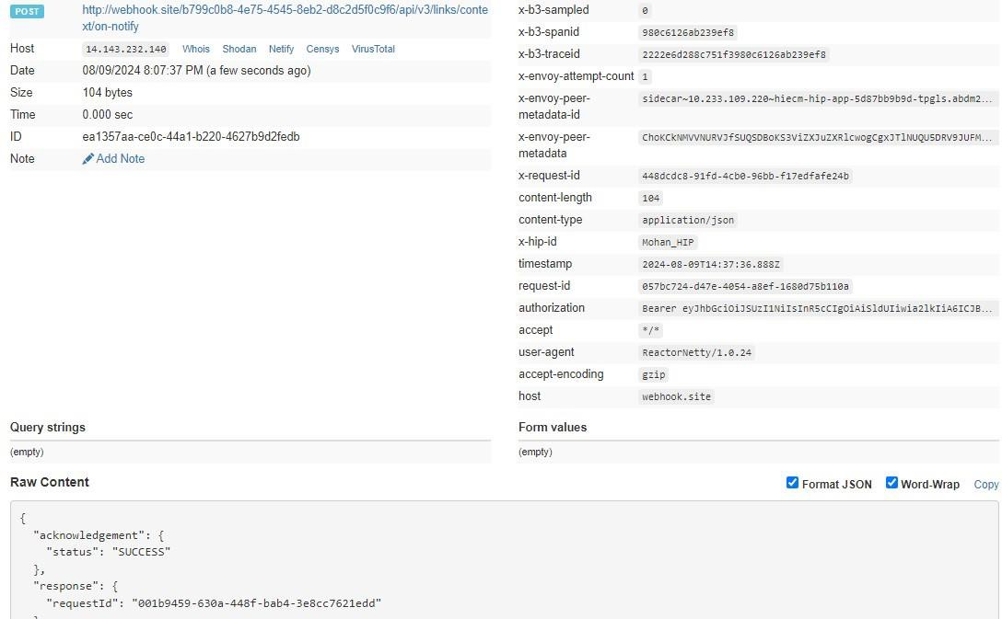

SMS Notification to patients

This API will be invoked by HIP to trigger a SMS notification to the patient mobile number when health record is available to fetch.

URL: /api/hiecm/hip/v3/link/patient/links/sms/notify2 Request: POST

Header Parameters:
Property  Name | Example Value | Required | Description

Authorization | eyJhbGciOiJSUzUxMiJ9. eyJzdWIiOiJ2 YXNhbnRoYWt1bWFyLmtlc2F2  YW5Ac2J4IiwiY2xpZW50SWQiOiJzYngi LCJzeXN0ZW0iOiJBQkhBLUEiLCJy  ZXF1ZXN0ZXJJZCI6IlBIUi1XRUIiLCJwaHJ  Nb2JpbGUiOm51bGwsImV4c  CI6MTY2NzI5ODExNSwiaWF0IjoxNjY3Mj kwOTE1LCJwaHJBZ  GRyZXNzIjoidmFzYW50aGFrdW1hci5rZ XNhdmFuQHNieCIsInR4bklkIjoi  YjEwMGM4ZDMtNTE1ZC00YWFiLTg1OW  QtYzNlMTUwOTE3ZGY1In0 | Yes | JWT Access token which was issued by ABDM session API after successful  validation of client id and secret
REQUEST-ID | 18235d89-cb13-479d-ad71-  7a57d5f669a8 | Yes | Unique UUID for tracking the end-to-end request transaction
TIMESTAMP | 2023 -03-09T07:07:41.793Z | Yes | The actual time when the request was initiated, ISO Date time format represents the date and time
X-CM-ID | sbx | Yes | Suffix of the consent manager to which the request was intended
Body Parameters:
Property Name | Example Value | Required | Description
requestId | 18235d89-cb13-479d-ad71-  7a57d5f669a8 | Yes | The id will be unique value to identify each notification requests.
phoneNo | 9876543210 | Yes | Mobile number of the patient.
hip | "hip": {  "name": "HIP Name", "id": "TestClinicHIP"  } | Yes | Identifier and name of the health information provider.

Request Body:
Request Body:

{
"requestId": "743ec386-670f-43a8-a3ed-44aa30fb15fb", "timestamp": "2024-05-09T10:34:00.387Z",
"notification": {
"phoneNo": "986543210",
"hip": {
"id": "ABDM_HIP",
"name": "ABC Hospital"
}
}
}

Error scenarios:

Scenarios | Headers/Body |  |  | Message
To verify when Request ID is Blank, null or  empty in  header | [  ] | {  } | "key": "REQUEST-ID",  "value": "",  "type": "text" | Access Denied  Code : 403 Forbidden
To verify when  invalid RequestID is pass in header | [  ] | {  } | "key": "REQUEST-ID",  "value": "{{$guid}}zxzzxs", "type": "text" | {  "code": "ABDM-1030: ",  "message": "Invalid requ est ID"  }  Code: 400Bad Request
When  Timestamp is  Blank, null or empty in header. | [  ] | {  } | "key": "TIMESTAMP",  "value": "",  "type": "text" | Access Denied  Code : 403 Forbidden
When invalid  Timestamp is pass in header | [  ] | {  } | "key": "TIMESTAMP",  "value": "{{$isoTimestamp}}jhgftytgtyu", "type": "text" | {  "code": "ABDM-1016: ",  "message": "Invalid Time stamp"  }  Code - 400Bad Request
Access Denied
Code : 403 Forbidden

When X-CM-ID | [ |  |  | Access Denied
is Invalid, Blank, null  or empty in header. |  | { | "key": "X-CM-ID", | Code : 403 Forbidden
 |  |  | "value": "sbxdvdfvdf",
 |  |  | "type": "text"
 |  | }
 | ]
When given HIP id |  |  |  | {
does not exist. |  |  |  | "code": "ABDM-1035: ",
 |  |  |  | "message": "Invalid HIP
 |  |  |  | ID"
 |  |  |  | }
Response Body:
Response
Code : 202 Accepted

Callback API for SMS Notification to patients

This is a callback API triggered by HIE-CM to notify HIP/HRP about SMS notification response.
URL: {callbackURL}/api/v3/patients/sms/on-notify Request: POST
Header Parameters:
Property  Name | Example Value | Required | Description
Authorization | eyJhbGciOiJSUzUxMiJ9. eyJzdWIiOiJ2 YXNhbnRoYWt1bWFyLmtlc2F2  YW5Ac2J4IiwiY2xpZW50SWQiOiJzYngi LCJzeXN0ZW0iOiJBQkhBLUEiLCJy  ZXF1ZXN0ZXJJZCI6IlBIUi1XRUIiLCJwaHJ  Nb2JpbGUiOm51bGwsImV4c  CI6MTY2NzI5ODExNSwiaWF0IjoxNjY3Mj kwOTE1LCJwaHJBZ  GRyZXNzIjoidmFzYW50aGFrdW1hci5rZ XNhdmFuQHNieCIsInR4bklkIjoi  YjEwMGM4ZDMtNTE1ZC00YWFiLTg1OW  QtYzNlMTUwOTE3ZGY1In0 | Yes | JWT Access token which was issued by ABDM session API after successful  validation of client id and secret
REQUEST-ID | 18235d89-cb13-479d-ad71-  7a57d5f669a8 | Yes | Unique UUID for tracking the endto-end request transaction
TIMESTAMP | 2023 -03-09T07:07:41.793Z | Yes | The actual time when the request was initiated, ISO Date time format represents the date and time
X-HIP-ID | IN2810014366 | Yes | Identifier of the health information provider to which the request was intended
Body Parameters:

Property  Name | Example Value | Required | Description
requestId | 18235d89-cb13-479dad71-  7a57d5f669a8 | Yes | Unique UUID for tracking the end-to-end request transaction
timestamp | 2023 -03-09T07:07:41.793Z | Yes | The actual UTC time when the request was initiated, ISO Date time format represents the date and time
status | “status": “SUCCESS" | Yes | Status of the  /hiecm/api/v3/link/patient/links/sms/notify2 API call.
error | "error": {  "code": "ABDM-1024",  "message": "Dependent service unavailable"  } | No | The error code and message if the notify request is failed.
resp | “resp“: {  “requestId”: “18235d89cb13-479d-ad717a57d5f6656a”  } | Yes | requestId from the  /hiecm/api/v3/link/patient/links/sms/notify2 API call.

Request Body:

Request Body:
{
"requestId": "743ec386-670f-43a8-a3ed-44aa30fb15fb", "timestamp": "2024-05-09T10:34:00.387Z",
"status": "SUCCESS", "error": {
"code": "ABDM-1024",
"message": "Dependent service unavailable"
},
"resp": {
"requestId": "6f0b4665-a915-4c92-aa36-65afb4a2cd71"
}
}

Response Body:
Response

Code : 202 Accepted
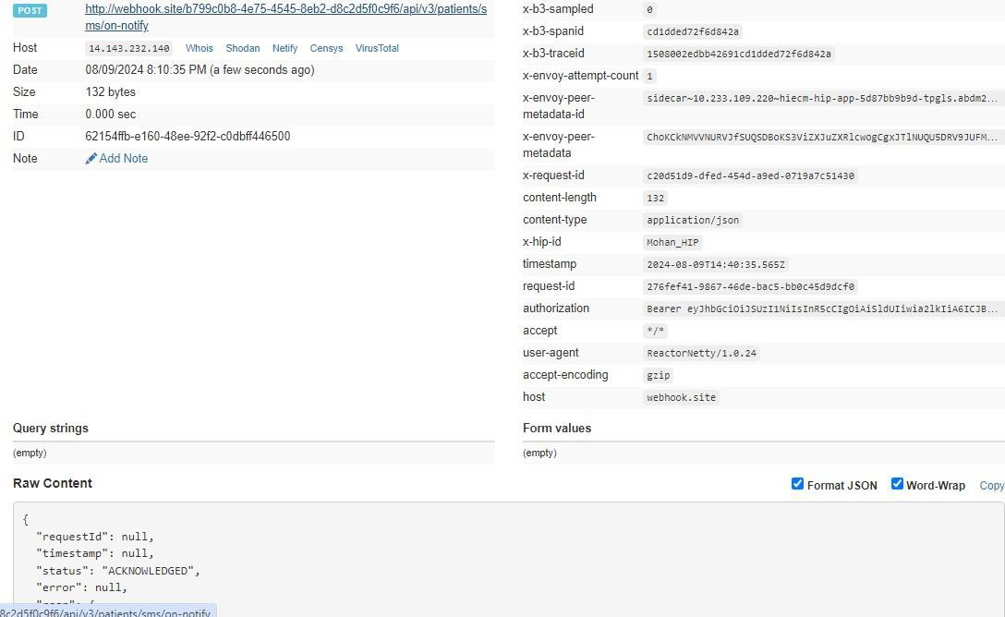

User Initiated Linking

Overview
User-initiated linking is the process in which Users/Patient search for their health records from ABDM-compliant health facilities. Once health records are found, users can link their health records with their ABHA address.
The user must have a Patient HIU (PHR App in the current scenario) via which the user can start the discovery of health records and link the health records for future reference.

Following are the steps involved in User initiated linking
- User searches for a health facility that they have visited in the past.
- The health facility must be a HIP (part of the facility registry) and linked with an HRP for discovery to be supported
- User makes a discovery request via Patient HIU (PHR App) – i.e., requests the HIP to find any health records in their name
- User shares his/her details through their PHR address. Details shared- Name, Date of birth, Gender, verified mobile no. with the HIP / HRP
- The HRP/HIP is expected to search its database for any records that match this patient.

- If there is a match, the HRP/HIP returns with the Care Context details for the records available
- If there is no match, the HRP/HIP returns an error
- The User can now request to link the records (care contexts) with their PHR address
- The HRP/HIP will perform the validation by sending an OTP to the registered mobile.
- If the authentication succeeds, the care contexts are linked to the PHR address

Sequence Diagram

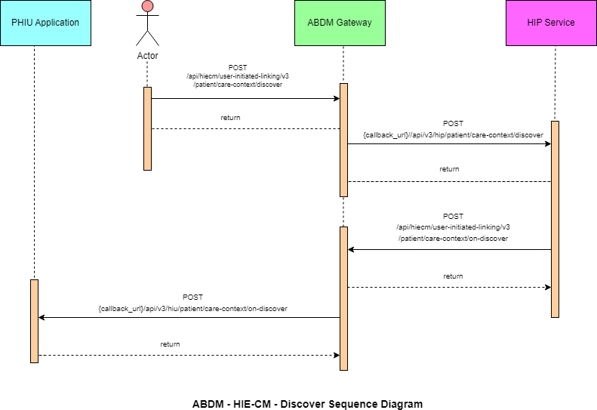
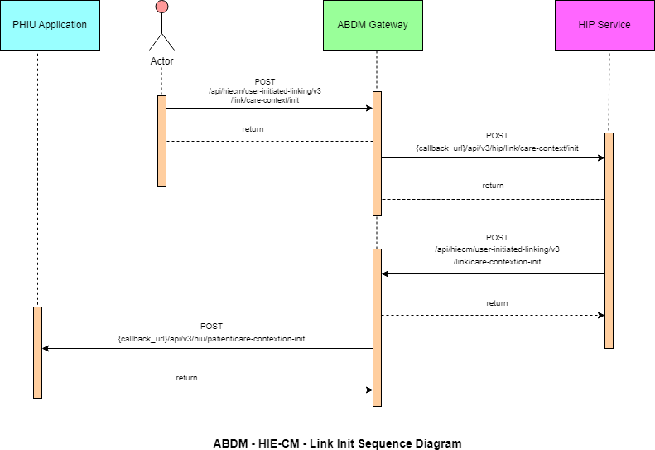

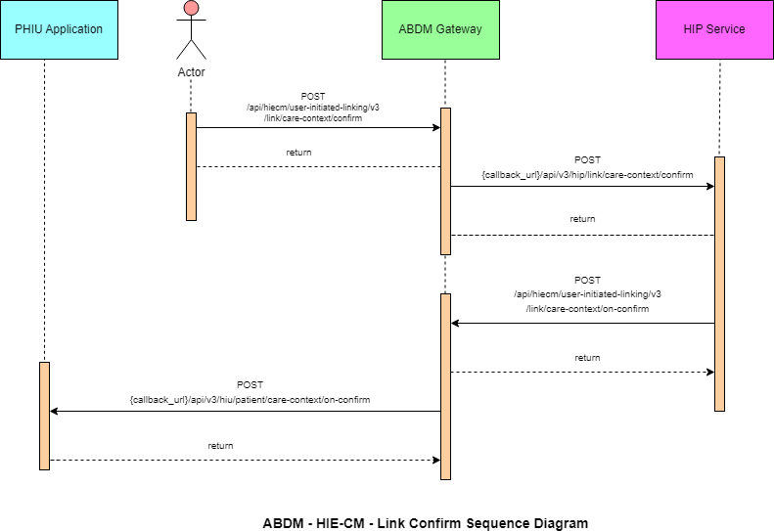

List of APIs

Patient Health record discovery
This API will be invoked by the patient/user from the PHR application to HIECM to discover his/her health records.
URL: /api/hiecm/user-initiated-linking/v3/patient/care-context/discover Request: POST
Header Parameters:
Property  Name | Example Value | Required | Description
Authorization | eyJhbGciOiJSUzUxMiJ9. eyJzdWIiOiJ2 YXNhbnRoYWt1bWFyLmtlc2F2  YW5Ac2J4IiwiY2xpZW50SWQiOiJzYngi LCJzeXN0ZW0iOiJBQkhBLUEiLCJy  ZXF1ZXN0ZXJJZCI6IlBIUi1XRUIiLCJwaHJ  Nb2JpbGUiOm51bGwsImV4c  CI6MTY2NzI5ODExNSwiaWF0IjoxNjY3Mj kwOTE1LCJwaHJBZ  GRyZXNzIjoidmFzYW50aGFrdW1hci5rZ XNhdmFuQHNieCIsInR4bklkIjoi  YjEwMGM4ZDMtNTE1ZC00YWFiLTg1OW  QtYzNlMTUwOTE3ZGY1In0 | Yes | JWT Access token which was issued by ABDM session API after successful  validation of client id and secret

REQUEST-ID | 18235d89-cb13-479d-ad71-  7a57d5f669a8 | Yes | Unique UUID for tracking the end-to-end request transaction
TIMESTAMP | 2023 -03-09T07:07:41.793Z | Yes | The actual time when the request was initiated, ISO Date time format represents the date and time
X-AUTH-TOKEN | eyJhbGciOiJSUzUxMiJ9.eyJzdWIiOiJ2 YXNhbnRoYWt1bWFyLmtlc2F2 |  | JWT Authentication token which was issued by ABDM after  successful validation of username and password
X-CM-ID | sbx | Yes | Suffix of the consent manager to which the request was intended
X-HIU-ID | HIU_ID | Yes | Identifier of the health information user to which the request was intended

Body Parameters:
Property Name | Example Value | Required | Description
hipId | ABDM_HIP | Yes | Identifier of the health information provider to which the request was intended
unverifiedIdentifiers | {  "type": "ABHA_ADDRESS",  "value": "shaik.XXXX@sbx"  } | Yes | Identifiers using which the HIP will search the patient information in their records.

Request Body:

Request Body
{
"hipId": "ABDM_HIP",
"unverifiedIdentifiers": [
{
"type": "ABHA_ADDRESS",
"value": "shaik.XXXX@sbx"
}
]
}

Response Body:
Response
Code: 202 Accepted

Error scenarios:

Scenarios | Headers/Body |  |  | Message
To verify when Request ID is Blank, null or empty in  header | [  ] | {  } | "key": "REQUEST-ID",  "value": "",  "type": "text" | Access Denied  Code : 403 Forbidden
To verify when  invalid RequestID is pass in header | [  ] | {  } | "key": "REQUEST-ID",  "value": "{{$guid}}zxzzxs", "type": "text" | {  "code": "ABDM-1030: ",  "message": "Invalid reque st ID"  }  Code: 400Bad Request

When  Timestamp is  Blank, null or empty in header. | [  ] | {  } | "key": "TIMESTAMP",  "value": "",  "type": "text" | Access Denied  Code : 403 Forbidden
When invalid  Timestamp is pass in header | [  ] | {  } | "key": "TIMESTAMP",  "value": "{{$isoTimestamp}}jhgftytgtyu", "type": "text" | {  "code": "ABDM-1016: ",  "message": "Invalid Times tamp"  }  Code - 400Bad Request
When X-HIP-ID  is Blank, null or empty in header. | [  ] | {  } | "key": "X-HIP-ID",  "value": "",  "type": "text" | Access Denied  Code : 403 Forbidden
When X-CM-ID  is Invalid, Blank, null or empty in header. | [ | { | "key": "X-CM-ID",  "value": "sbxdvdfvdf", | Access Denied
 |  |  |  | Code : 403 Forbidden

 | "type": "text"
}
]
When X-Auth-TOKEN is Invalid in header. | [  {  "key": "X-LINK-TOKEN",  "value": "hghhjjkhjkbkjbjkbkjbnkjbk", "type": "text"  }  ] | {  ""code"": ""ABDM-1066: "",  ""message"": ""Invalid JWT token""  }  Code - 400Bad Request"
Verify when HIP is null, blank or  invalid in the body | {  "hip": {  "id": ""  },  "unverifiedIdentifiers": [  {  "type": "MR",  "value": "69128688344"  }  ]  } | {  "code": "ABDM-9999: ",  "message": "HIP ID is mandatory"  }
When X-HIU-ID and the hipId in the  payload is same. |  | {  ""code"": ""ABDM-1031  : "",  ""message"": HIP and HIU cannot be same""  }  Code - 400Bad Request"
When duplicate request payload is sent. |  | {  "code": "ABDM-1103: ",  ""message"": “Duplicate Discovery request“  }  Code - 400Bad Request"

HIE-CM callback to HIP - Discovery
This is a callback API invoked by HIE-CM to let the HIP know about the discovery request raised by the patient using HIE-CM’s discovery.
URL: {callback_url}/api/v3/hip/patient/care-context/discover

Request: POST

Header Parameters:

Property  Name | Example Value | Required | Description
REQUEST-ID | 18235d89-cb13-479d-ad71-7a57d5f669a8 | Yes | Unique UUID for  tracking the endto-end request transaction
TIMESTAMP | 2022-10-06T10:10:00.587Z | Yes | The actual time when the request was initiated, ISO Date time format represents the date and time
X-HIP-ID | HIP_ID | Yes | Identifier of the health information provided to which the request was intended
Body Parameters:
roperty Name  transactionId | Example Value  03813343-ebc5-4c9f- Yes unique transaction for use | Required  Transaction Id is r-initiated | Description  required to identify the 89b6-6e9a75fd7c92  care context linking. This chains all the steps to link care contexts. Transaction Id will be returned after a successful discovery request to HIP by the  patient.
atient | - | Yes | A list of records of the patient that were  found as a result of the identifiers that the patien had provided.
Id 9162484106XXX | X@sbx Yes ABHA | Address of the pati | ent verifiedIdentifiers - Yes
Identification de | tails of the patient like |  | the Mobile number and Abha Number.
nverifiedIdentifiers- |  | Yes | The identification details provided by the patient in Discover API body
Name User 1 Yes Name o | f the patient Gender M Yes G | ender of the user
earOfBirth | XXXX | Yes | Year of Birth of the patient

P

p
t

u

y

Request Body:

{
"transactionId": "03813343-ebc5-4c9f-89b6-6e9a75fd7c92", "patient": {
"id": "9167@sbx",
"verifiedIdentifiers": [
{
"type": "MOBILE",
"value": "987654XXXX"
},
{
"type": "ABHA_NUMBER", "value": "916248419XXXX"
}
],
"unverifiedIdentifiers": [
{
"type": "MR",
"value": "987654XXXX"
}
],
"name": "User 1",
"gender": "M",
"yearOfBirth": XXXX
}
}

Response
Code: 200 OK
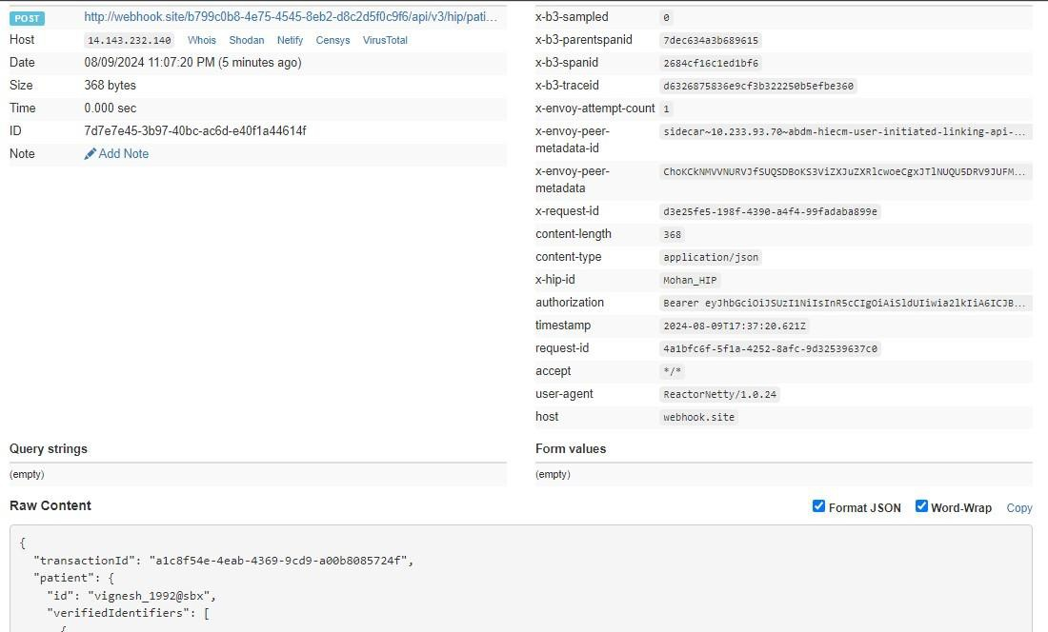

HMIS/LMIS response on health record discover

This API will be invoked by the HMIS/LIMS application for sharing the response of discover request.
URL: /api/hiecm/user-initiated-linking/v3/patient/care-context/ondiscover

Request: POST

Header Parameters:
Property  Name | Example Value | Required | Description
Authorization | eyJhbGciOiJSUzUxMiJ9. eyJzdWIiOiJ2YXNhbnRoY Wt1bWFyLmtlc2F2YW5Ac2J4IiwiY2xpZW50SWQiOi  JzYngiLCJzeXN0ZW0iOiJBQkhBLUEiLCJyZXF1ZXN0Z XJJZCI6IlBIUi1XRUIiLCJwaHJNb2JpbGUiOm51bGw  sImV4cCI6MTY2NzI5ODExNSwiaWF0IjoxNjY3Mjkw OTE1LCJwaHJBZGRyZXNzIjoidmFzYW50aGFrdW1h ci5rZXNhdmFuQHNieCIsInR4bklkIjoiYjEwMGM4ZD  MtNTE1ZC00YWFiLTg1OWQtYzNlMTUwOTE3ZGY1In0 | Yes | JWT Access token which was issued by ABDM session API after successful validation of client id and secret
REQUEST-ID | 18235d89-cb13-479d-ad71-7a57d5f669a8 | Yes | Unique UUID for tracking the end-toend request  transaction
TIMESTAMP | 2022-10-06T10:10:00.587Z | Yes | The actual time when the request was initiated, ISO Date time format represents the date and time
X-CM-ID | sbx | Yes | Suffix of the consent manager to which the request was intended
Body Parameters:
Property  Name | Example Value | Required | Description

transactionId | f901b782-bfdf-4224-9f8d-da2cadc20c0d | Yes | Transaction Id is required to identify the unique  transaction for user-initiated care context linking. This chains all the steps to link care contexts.  Transaction Id will be returned after a successful discovery request to HIP by the patient.
patient | - | Optional | A list of records of the patient that were found as a result of the identifiers that the patient had provided.
referenceNumber | example01 | Yes | Reference number of the patient details
careContexts | - | Yes | List of care contexts linked at the HIP end for the identified patient.
hiType | PRESCRIPTION | Yes | HiType of the patient details
count | 1 | Yes | The count of care contexts that are found for the patient in scope
requestId | 2c17a46b-d28e-4a60a7cf-fe77163ae93c | Yes | Request ID sent by the patient in the discovery API call. This request ID will be used to match the flow of linking care contexts for a patient
Error | {  "code": "ABDM-1010",  "message": "Patient not found"  } | Optional | The error should be included if no details are found for the patient at HIP for the  given patient identifiers. The error should contain ABDM standard code and message to indicate the reason properly.
matchedBy | MR | Yes | How the records are matched

Request Body
Success Scenario:

{
"transactionId": "66446ece-396b-4f22-a1a6-756196fdffc9", "patient": [
{
"referenceNumber": "example01", "display": "abcd-display",
"careContexts": [
{
"referenceNumber": "abcd", "display": "123-display"
}
],
"hiType": "PRESCRIPTION",
"count": 1
}
],
"matchedBy": [ "MR"
],
"response": {
"requestId": "2c17a46b-d28e-4a60-a7cf-fe77163ae93c"
}
}
Failure Scenario:
{
"transactionId": "66446ece-396b-4f22-a1a6-756196fdffc9", "error": {
"code": "ABDM-1010",
"message": "Patient not found"
},
"response": {
"requestId": "2c17a46b-d28e-4a60-a7cf-fe77163ae93c"
}
}

Response:

Response
Code: 202 Accepted
Error Scenarios:

Scenarios | Headers/Body | Message
To verify when Request ID is Blank, null or empty in header | [  {  "key": "REQUEST-ID",  "value": "",  "type": "text"  }  ] | Access Denied  Code : 403 Forbidden

To verify when invalid Request-ID is pass in header | [  {  "key": "REQUEST-ID",  "value": "{{$guid}}zxzzxs", "type": "text"  }  ] | {  "code": "ABDM-1030: ",  "message": "Invalid request I D"  }  Code: 400Bad Request
When Timestamp is Blank, null or empty in header. | [  {  "key": "TIMESTAMP",  "value": "",  "type": "text"  }  ] | Access Denied  Code : 403 Forbidden
When invalid Timestamp is pass in header | [  {  "key": "TIMESTAMP",  "value": "{{$isoTimestamp}  }jhgftytgtyu",  "type": "text"  }  ] | {  "code": "ABDM-1016: ",  "message": "Invalid Timesta mp"  }  Code - 400Bad Request
When X-CM-ID is Invalid, Blank, null or empty in header. | [  {  "key": "X-CM-ID",  "value": "sbxdvdfvdf", "type": "text"  }  ] | Access Denied  Code : 403 Forbidden

Verify when transaction id is invalid, null or blank | "transactionId": "776a9becab12-42bc-9ae9c63b1ae5bce2", "patient": [  {  "referenceNumber": "ST1", "display": "",  "careContexts": [  {  "referenceNumber": "S  T2",  "display": "ST2"  }  ],  "hiType": "PRESCRIPTION",  "count": 1  }  ],  "matchedBy": [ "MR"  ],  "response": {  "requestId": "6f37ddf8-62df-4 afe-bc25-599789c90558" | "code": "ABDM-9999: ",  "message": "Invalid Transactio n ID / Transaction expired."
Verify message when HI types is passed as incorrect | "transactionId": "776a9becab12-42bc-9ae9c63b1ae5bce2", "patient": [  {  "referenceNumber": "ST1", "display": "",  "careContexts": [  {  "referenceNumber": "S  T2",  "display": "ST2"  }  ],  "hiType": "PRESCRIPTION",  "count": 1  }  ],  "matchedBy": [ "MR"  ],  "response": {  "requestId": "6f37ddf8-62df4afe-bc25-599789c90558" | {  "code": "ABDM-9999: ",  "message": "Invalid HIType, it must be in PRESCRIPTION, DIAGNOSTI  CREPORT,  OPCONSULTATION, DISCHARGES UMMARY,  IMMUNIZATIONRECORD, HEALTH DOCUMENTRECORD, WELLNESSR ECORD"  }  400 Bad Request

Verify message when careconexts is | "transactionId": "776a9becab12- | {  "code": "ABDM-9999: ",  "message": "Invalid Care  Contexts count, must range be tween 1 to 20"  }
blank, null | 42bc-9ae9c63b1ae5bce2",
 | "patient": [
 | {
 | "referenceNumber": "ST1",
 | "display": "",
 | "careContexts": [
 | {
 | "referenceNumber": "S
 | T2",
 | "display": "ST2"
 | }
 | ],
 | "hiType": "PRESCRIPTION",
 | "count": 1
 | }
 | ],
 | "matchedBy": [
 | "MR"
 | ],
 | "response": {
 | "requestId": "6f37ddf8-62df-
 | 4 afe-bc25-599789c90558"
Verify if the requestId is a valid id from the discovery request. |  | {  "code": "ABDM-1015: ",  "message": "Invalid Response"  }

Verify if it is a duplicate request |  | {  "code": "ABDM-1106: ",  "message": "Duplicate On discovery request"  }  Code: 400Bad Request
Verify if the count and the no of care contexts matches in the payload. | "transactionId": "776a9becab12-42bc-9ae9c63b1ae5bce2", "patient": [  {  "referenceNumber": "ST1", "display": "",  "careContexts": [  {  "referenceNumber": "S  T2",  "display": "ST2"  }  ],  "hiType": "PRESCRIPTION",  "count": 2  }  ],  "matchedBy": [ "MR"  ],  "response": {  "requestId": "6f37ddf8-62df4afe-bc25-599789c90558" | {  "code": "ABDM-1059: ",  "message": "Invalid Care Contexts count"  }

HIE-CM callback on Health record discover
This API will be invoked by the HIE-CM for sharing the response of health record discover.

URL: {callback_url}/api/v3/hiu/patient/care-context/on-discover Request: POST
Header Parameters:
Property Name | Example Value | Required | Description
REQUEST-ID | 18235d89-cb13-479d-ad71-  7a57d5f669a8 | Yes | Unique UUID for tracking the end-to-end request transaction
TIMESTAMP | 2022-10-06T10:10:00.587Z | Yes | The actual time when the request was initiated, ISO Date time format represents the date and time
X-CM-ID | sbx | Yes | Identifier of the health information user to which the request was intended
Body Parameters:
Property Name | Example Value | Required | Description
transactionId | f901b782-bfdf4224-9f8dda2cadc20c0d | Yes | Transaction Id is required to identify the unique  transaction for user-initiated care context linking. This chains all the steps to link care contexts.  Transaction Id will be returned after a successful discovery request to HIP by the patient.
patient | - | Yes | A list of records of the patient that were found as a result of the identifiers that the patient had provided.
referenceNumber | example01 | Yes | Reference number of the patient details
careContexts | - | Yes | List of care contexts linked at the HIP end for the identified patient.
hiType | PRESCRIPTION | Yes | HiType of the patient details
Count | 1 | Yes | The count of care contexts that are found for the patient in scope
createdAt | 2023-06-  13T08:05:43.030Z | Yes | The time at which the on discover API is invoked
requestId | d89525a23a3f-4d39-  98b5-  477afb1865f6 | Yes | Request ID sent by in on-discover API call. This request ID will be used to match the flow of linking care contexts for a patient
Request Body:
Request Body:

{
"transactionId": "0d36501c-551a-4bb5-b247-eec4bb42984b", "patient": [
{
"referenceNumber": "example01", "display": "abcd-display",
"careContexts": [
{
"referenceNumber": "abcd", "display": "123-display"
}
],
"hiType": "PRESCRIPTION",
"count": 1
}
],
"createdAt": "2023-06-13T08:05:43.030Z",
"response": {
"requestId": "d89525a2-3a3f-4d39-98b5-477afb1865f6"
}
}

Response:

Response
Code: 200 OK
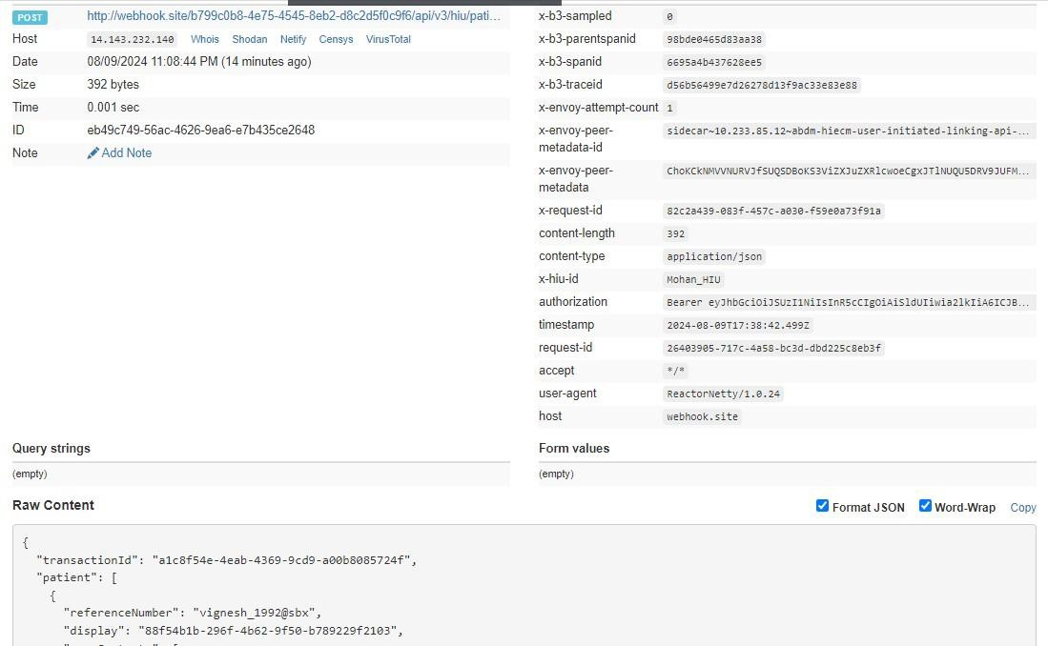

Patient health record link init
This API will be invoked by the patient to link his/her health records.

URL: /api/hiecm/user-initiated-linking/v3/link/care-context/init Request: POST
Header Parameters:
Property  Name | Example Value | Required | Description
Authorizatio n | eyJhbGciOiJSUzUxMiJ9. eyJzdWIiOiJ2YX NhbnRoYWt1bWFyLmtlc2F2YW5Ac2J4Ii wiY2xpZW50SWQiOiJzYngiLCJzeXN0ZW 0iOiJBQkhBLUEiLCJyZXF1ZXN0ZXJJZCI6Il  BIUi1XRUIiLCJwaHJNb2JpbGUiOm51bGw sImV4cCI6MTY2NzI5ODExNSwiaWF0Ijox NjY3MjkwOTE1LCJwaHJBZGRyZXNzIjoid mFzYW50aGFrdW1hci5rZXNhdmFuQHNi eCIsInR4bklkIjoiYjEwMGM4ZDMtNTE1ZC0 0YWFiLTg1OWQtYzNlMTUwOTE3ZGY1In0 | Yes | JWT Access token which was issued by ABDM session API after successful  validation of client id and secret
REQUEST-ID | 18235d89-cb13-479d-ad71-  7a57d5f669a8 | Yes | Unique UUID for track the end-toend request transaction
TIMESTAMP | 2022-10-06T10:10:00.587Z | Yes | Actual time when request was initiated, ISO Date time format represents date and time
X-AUTHTOKEN | eyJhbGciOiJSUzUxMiJ9.eyJzdWIiOiJ2 YXNhbnRoYWt1bWFyLmtlc2F2 |  | JWT Authentication token which was issued by ABDM after successful  validation of username and password
X-HIU-ID | HIU_ID | Yes | Identifier of the health information user by which the request was initiated
X-CM-ID | sbx | Yes | Suffix of the consent manager to which the request was intended
Body Parameters:
Property Name | Example Value | Required | Description
transactionId | f901b782-  bfdf4224-  9f8dda2cadc20c0d | Yes | Transaction Id is required to identify the unique  transaction for user-initiated care context linking. This chains all the steps to link care contexts. Transaction Id will be returned after successful discovery request to HIP by the patient.
abhaAddress | user_123@sbx | No | The abha address of the patient
patient | - | Yes | A list of records of the patient that were found as a result of the identifiers that the patient had provided.

referenceNumber | example01 | Yes | Reference number of the patient details
careContexts | - | Yes | List of care contexts linked at the HIP end for the identified patient.
hiType | PRESCRIPTION | Yes | HiType of the patient details
Count | 1 | Yes | The count of care contexts that are found for the patient in scope

Request Body:
Request Body:
{
"transactionId": "66446ece-396b-4f22-a1a6-756196fdffc9", "abhaAddress": "user_123@sbx",
"patient": [
{
"referenceNumber": "example01", "careContexts": [
{
"referenceNumber": "123"
}
],
"hiType": "PRESCRIPTION",
"count": 1
}
]
}
Response:
Response
Code : 202 Accepted

Error scenarios:

Scenarios | Headers/Body | Message

Verify when  transaction id is invalid, null or blank | "transactionId": "", "error": {  "code": "ABDM-1010",  "message": "test"  },  "response": {  "requestId": "926ca4ad-aef5-4937-a26cc2b529464566"  } | "code": "ABDM-9999: ",  "message" : "Invalid Transaction ID"

Verify  message when count is incorrect | "transactionId": "776a9bec-ab12-42bc9ae9-c63b1ae5bce2",  "patient": [  {  "referenceNumber": "Testing defect", "careContexts": [  {  "referenceNumber": "1234",  "display": "12"  } ],  "hiType": "PRESCRIPTION",  "count": 0 } | "{  "code": "ABDM-1059: ",  "message": "Invalid Care Contexts count"  }"
To verify when Request ID is Blank, null or  empty in header | [  {  "key": "REQUEST-ID",  "value": "",  "type": "text"  }  ] | Access Denied  Code : 403 Forbidden
To verify when invalid Request-ID is pass in header | [  {  "key": "REQUEST-ID",  "value": "{{$guid}}zxzzxs", "type": "text"  }  ] | {  "code": "ABDM-1030: ",  "message": "Invalid request ID"  }  Code: 400Bad Request

When  Timestamp  is Blank, null or empty in header. | [  {  "key": "TIMESTAMP",  "value": "",  "type": "text"  }  ] | Access Denied  Code : 403 Forbidden

When invalid Timestamp  is pass in header | [  {  "key": "TIMESTAMP",  "value": "{{$isoTimestamp}}jhgftytgtyu", "type": "text"  }  ] | {  "code": "ABDM-1016: ",  "message": "Invalid Timestamp"  }  Code - 400Bad Request
When X-CM-ID is Invalid,  Blank, null or  empty in header. | [  {  "key": "X-CM-ID",  "value": "sbxdvdfvdf", "type": "text"  }  ] | Access Denied  Code : 403 Forbidden
When X-HIU-ID is Blank, null or empty in  header. | [  {  "key": "X-HIU-ID",  "value": "",  "type": "text"  }  ] | Access Denied  Code : 403 Forbidden
When XAUTH-TOKEN  is Invalid, Blank, null or empty in header. | [  {  "key": "X-CM-ID",  "value": "sbxdvdfvdf", "type": "text"  }  ] | {  "code": "ABDM-1065: ",  "message": "Invalid X Auth token"  }

When the  careContexts is null or empty. | "transactionId": "776a9bec-ab12-42bc9ae9-c63b1ae5bce2",  "patient": [  {  "referenceNumber": "Testing defect", "careContexts": [],  "hiType": "PRESCRIPTION",  "count": 0 } | {  "code": "ABDM-1057: ",  "message": "Invalid Care Contexts"  }
When  link/init is called after discovery request expired. |  | {  "code": "ABDM-1086: ",  "message": "Invalid Transaction ID / Transaction expired."  }

HIE-CM callback on health record link init
This API will be invoked by the HIE-CM to initiate the linking of patient health records to HIP.

URL: {callback_url}/api/v3/hip/link/care-context/init Request: POST
Header Parameters:
Property Name | Example Value | Required | Description
REQUEST-ID | 18235d89-cb13-479dad71-  7a57d5f669a8 | Yes | Unique UUID for tracking the end-to-end request  transaction
TIMESTAMP | 2022-10-  06T10:10:00.587Z | Yes | The actual time when the request was initiated, ISO Date time format represents the date and time
X-HIP-ID | IN2810014366 | Yes | Identifier of the health information provider to which the request was intended

Authorization | eyJhbGciOiJSUzUxMiJ9. eyJzdWIiOiJ2YXNhbnRoY Wt1bWFyLmtlc2F2YW5Ac  2J4IiwiY2xpZW50SWQiOi | Yes | JWT Access token which was issued by ABDM session API after successful validation of client id and secret
 | JzYngiLCJzeXN0ZW0iOiJ
 | BQkhBLUEiLCJyZXF1ZXN0Z
 | XJJZCI6IlBIUi1XRUIiLCJwa
 | HJNb2JpbGUiOm51bGws
 | ImV4cCI6MTY2NzI5ODEx
NSwiaWF0IjoxNjY3MjkwO TE1LCJwaHJBZGRyZXNzIjo
idmFzYW50aGFrdW1hci5 rZXNhdmFuQHNieCIsInR 4bklkIjoiYjEwMGM4ZDMt
 | NTE1ZC00YWFiLTg1OWQtY zNlMTUwOTE3ZGY1In0
Body Parameters:
Property Name | Example Value | Required | Description
transactionId | f901b782-bfdf-4224-9f8d-da2cadc20c0d | Yes | Transaction Id is required to identify the unique  transaction for user-initiated care context linking. This chains all the steps to link care contexts.  Transaction Id will be returned after a successful discovery request to HIP by the patient.
abhaAddress | 9162484106XXXX@sbx |  | ABHA addresses which the linking of care contexts should be initiated by the HIP.
patient | - | Yes | A list of records of the patient that were found as a result of the identifiers that the patient had provided.
referenceNumber | example01 | Yes | Reference number of the patient details
careContexts | - | Yes | List of care contexts linked at the HIP end for the identified patient.
hiType | PRESCRIPTION | Yes | HiType of the patient details
Count | 1 | Yes | The count of care contexts that are found for the patient in scope
Request Body:
Request Body:

{
"transactionId": "5042908f-dac4-43dd-99b9-9b5bedad32ea", "abhaAddress": "9162484106XXXX@abdm",
"patient": [
{
"referenceNumber": "example01", "careContexts": [
{
"referenceNumber": "123"
}
],
"hiType": "PRESCRIPTION",
"count": 1
}
]
}

Response:

Response
Code : 200 OK
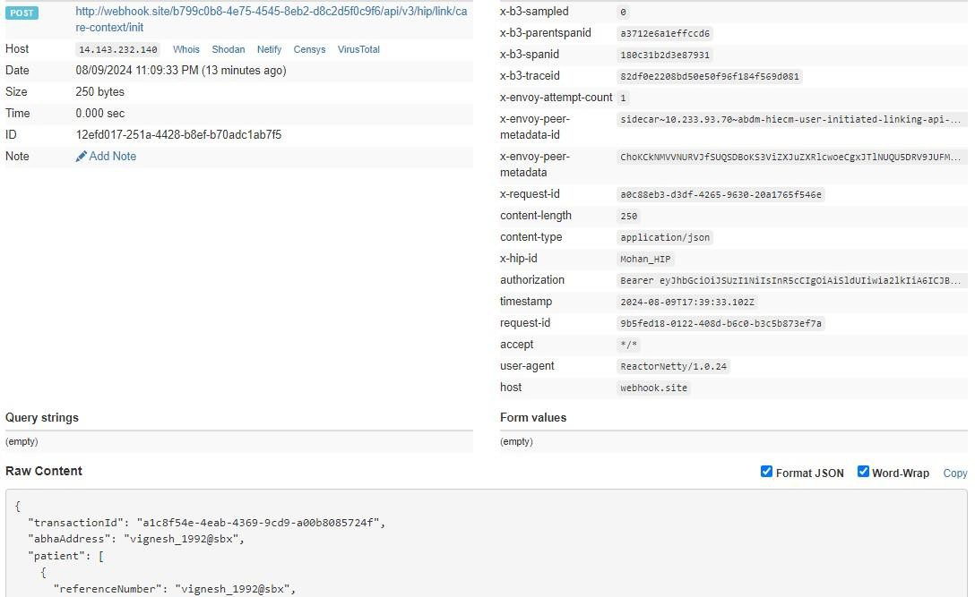

HMIS/LMIS response on health record link

This API will be invoked by the HMIS/LMIS to share the response of link init API (referenceNumber will be generated by HIP and this will used in the confirm API)
URL: /api/hiecm/user-initiated-linking/v3/link/care-context/on-init

Request: POST

Header Parameters:
Property  Name | Example Value | Required | Description
Authorization | eyJhbGciOiJSUzUxMiJ9. eyJzdWIiOiJ2YXNhb nRoYWt1bWFyLmtlc2F2YW5Ac2J4IiwiY2xpZW 50SWQiOiJzYngiLCJzeXN0ZW0iOiJBQkhBLUEi  LCJyZXF1ZXN0ZXJJZCI6IlBIUi1XRUIiLCJwaHJN | Yes | JWT Access token which was issued by ABDM session API after successful
 | b2JpbGUiOm51bGwsImV4cCI6MTY2NzI5ODE xNSwiaWF0IjoxNjY3MjkwOTE1LCJwaHJBZGRy ZXNzIjoidmFzYW50aGFrdW1hci5rZXNhdmFu  QHNieCIsInR4bklkIjoiYjEwMGM4ZDMtNTE1ZC0  0YWFiLTg1OWQtYzNlMTUwOTE3ZGY1In0 |  | validation of client id and secret
REQUEST-ID | 18235d89-cb13-479d-ad71-7a57d5f669a8 | Yes | Unique UUID for track the end to end request transaction
TIMESTAMP | 2022-10-06T10:10:00.587Z | Yes | Actual time when request was initiated, ISO Date time format represents date and time
X-CM-ID | sbx | Yes | Suffix of the consent manager to which the request was intended
Body Parameters:
Property  Name | Example Value | Required | Description
transactionId | f901b782-bfdf-4224-9f8d-da2cadc20c0d | Yes | Transaction Id is required to identify the unique transaction for user initiated  care context linking. This chains all the steps to link care contexts.Transaction Id will be returned after successful  discovery request to HIP by the patient.

Link | {  "referenceNumber": "3336268d-89a34c84-8674-aef42092d9fc",  "authenticationType": "MEDIATE", "meta": {  "communicationMedium": "MOBILE", "communicationHint": "OTP",  "communicationExpiry": "2023-1230T12:01:55.324Z"  } | Yes | The details of the link using which the records has to be linked to the patient’s ABHA account. It will contain details like the referenceNumber, authenticationType and the meta details of the link
requestId | 2b835afb-0c97-4ce7-9dd9ef58ee98a326 | Yes | Request ID sent in init API call. This request ID will be used to match the flow of linking care contexts for a patient
Request Body:
Request Body:
{
"transactionId": "66446ece-396b-4f22-a1a6-756196fdffc9",
"link": {
"referenceNumber": "3336268d-89a3-4c84-8674-aef42092d9fc", "authenticationType": " MEDIATE",
"meta": {
"communicationMedium": "MOBILE", "communicationHint": "OTP",
"communicationExpiry": "2023-12-30T12:01:55.324Z"
}
},
"response": {
"requestId": "2b835afb-0c97-4ce7-9dd9-ef58ee98a326"
}
}

Response:
Response
Code : 202 Accepted

Error scenarios:

Scenarios | Headers/Body | Message

Verify when transaction id is invalid, null or blank | {  "transactionId": "", "link": {  "referenceNumber": "Testing defe ct", "authenticationType": " MEDIATE",  "meta": {  "communicationMedium": "MO  BILE",  "communicationHint": "OTP",  "communicationExpiry": "202306-31T12:33:37.603Z"  }  },  "response": {  "requestId": "3a95d49d-c06b46cf-99b4-695ec53316e2"  }  } | “Code”: " ABDM-9999: ",  “message”: "Invalid Transaction Id ."

Verify message when communication  expiry date is invalid or null | "{  ""transactionId"": """", ""link"": {  ""referenceNumber"": ""Testing defe ct"", ""authenticationType"": ""DIRECT"",  ""meta"": {  ""communicationMedium"": ""MO BILE"",  ""communicationHint"": ""OTP"", ""communicationExpiry"": ""2023-  06-31T12: 33: 37.603Z""  }  },  ""response"": {  ""requestId"": ""3a95d49d-c06b46cf-99b4-695ec53316e2""  }  } " | {  "code": "ABDM-9999: ",  "message": "Invalid communica tion expiry date."  }  400 Bad Request

Verify message when request ID is invalid or null | "{  ""transactionId"": """", ""link"": {  ""referenceNumber"": ""Testing defe ct"", ""authenticationType"": "" MEDIATE"",  ""meta"": {  ""communicationMedium"": ""MO BILE"",  ""communicationHint"": ""OTP"", ""communicationExpiry"": ""2023-  06-31T12: 33: 37.603Z""  }  },  ""response"": {  ""requestId"": ""3a95d49d-c06b46cf-99b4-695ec53316e2""  }  }" | {  "code": "ABDM-9999: ",  "message": "Invalid request ID"  }  400 Bad Request
When the referenceNumber is null or empty. | {  "transactionId": "", "link": {  "referenceNumber": ", "authenticationType": " MEDIATE", "meta": {  "communicationMedium": "MOBIL  E",  "communicationHint": "OTP",  "communicationExpiry": "2023-  06-31T12: 33: 37.603Z"  } | {  "code": "ABDM-9999: ",  "message": "Invalid reference number."  }

},
"response": {
"requestId”: "3a95d49d-c06b46cf-99b4-695ec53316e2"
}
}

When the authenticationTypeis null or empty. | {  "transactionId": "", "link": {  "referenceNumber": “12345", "authenticationType": "",  "meta": {  "communicationMedium": "MOBIL  E",  "communicationHint": "OTP",  "communicationExpiry": "2023-  06-31T12: 33: 37.603Z"  }  },  "response": {  "requestId”: "3a95d49d-c06b46cf-99b4-695ec53316e2"  }  } | {  "code": "ABDM-9999: ", "message": “Invalid authentication type”  }
When the communicationMedi um is null or empty. | {  "transactionId": "3a95d49d-c06b46cf-99b4-695ec53316e2",  "link": {  "referenceNumber": “12345", "authenticationType": "",  "meta": {  "communicationMedium": "", "communicationHint": "OTP",  "communicationExpiry": "2023-  06-31T12: 33: 37.603Z"  }  },  "response": {  "requestId”: "3a95d49d-c06b46cf-99b4-695ec53316e2"  }  } | {  "code": "ABDM-9999: ",  "message": “Invalid communication medium”  }

When the communicationHint is null or empty. | {  "transactionId": "3a95d49d-c06b46cf-99b4-695ec53316e2",  "link": {  "referenceNumber": “12345", "authenticationType": "",  "meta": {  "communicationMedium": "DIREC  T",  "communicationHint": "",  "communicationExpiry": "2023-  06-31T12: 33: 37.603Z"  }  },  "response": {  "requestId”: "3a95d49d-c06b46cf-99b4-695ec53316e2"  }  } | {  "code": "ABDM-9999: ", "message": “Invalid communication hint”  }

HIE-CM response on health record link

This is a callback API that will be invoked by the HIE-CM to share the response of the link on-init request from HIP
URL: {callback_url}/api/v3/hiu/patient/care-context/on-init Request: POST
Header Parameters:
Property Name | Example Value | Required | Description
Authorization | eyJhbGciOiJSUzUxMiJ9. eyJzdWIiOiJ2YXNhbnRoY Wt1bWFyLmtlc2F2YW5Ac 2J4IiwiY2xpZW50SWQiOi JzYngiLCJzeXN0ZW0iOiJ  BQkhBLUEiLCJyZXF1ZXN0Z XJJZCI6IlBIUi1XRUIiLCJwa  HJNb2JpbGUiOm51bGws ImV4cCI6MTY2NzI5ODEx  NSwiaWF0IjoxNjY3MjkwO TE1LCJwaHJBZGRyZXNzIjo  idmFzYW50aGFrdW1hci5 rZXNhdmFuQHNieCIsInR 4bklkIjoiYjEwMGM4ZDMt NTE1ZC00YWFiLTg1OWQtY zNlMTUwOTE3ZGY1In0 | Yes | JWT Access token which was issued by ABDM session API after successful validation of client id and secret.

REQUEST-ID | 18235d89-cb13-479dad71-  7a57d5f669a8 | Yes | Unique UUID for track the end to end request transaction
TIMESTAMP | 2022-10-  06T10:10:00.587Z | Yes | Actual time when request was initiated, ISO Date time format represents date and time
X-HIU-ID | IN2810014366 | Yes | Identifier of the health information user to which the request was intended
Body Parameters:
Property  Name | Example Value | Required | Description
transactionId | f901b782-bfdf-4224-9f8d-da2cadc20c0d | Yes | Transaction Id is required to identify the unique transaction for user initiated care context linking. This chains all the steps to link care contexts.Transaction Id will be returned after successful discovery request to HIP by the patient.
Link | {  "referenceNumber": "4336268d-89a34c84-8674-aef42092d9fc",  "authenticationType": " MEDIATE", "meta": {  "communicationMedium": "MOBILE", "communicationHint": "OTP",  "communicationExpiry": "2023-1230T12:01:55.324Z"  }  } | No | The details of the link using which the records have to be linked to the patient’s ABHA account. It will contain details like the referenceNumber,  authenticationType and the meta details of the link
error | "error": {  "code": 1000,  "message": "string"  } | No | The error code and message if any occurred.
requestId | 2b835afb-0c97-4ce7-9dd9ef58ee98a326 | Yes | Request ID sent in init API call. This request ID will be used to match the flow of linking care contexts for a patient
Request Body:
Request Body:

{
"transactionId": "5b39f73e-b19a-421a-ab43-c97cbd903041", "link": {
"referenceNumber": "4336268d-89a3-4c84-8674-aef42092d9fc", "authenticationType": " MEDIATE",
"meta": {
"communicationMedium": "MOBILE", "communicationHint": "OTP",
"communicationExpiry": "2023-12-30T12:01:55.324Z"
}
},
"response": {
"requestId": "14a298b4-cf4a-497b-b4c1-72b50295fb91"
}
}

Response:

Response
Code : 202 Accepted
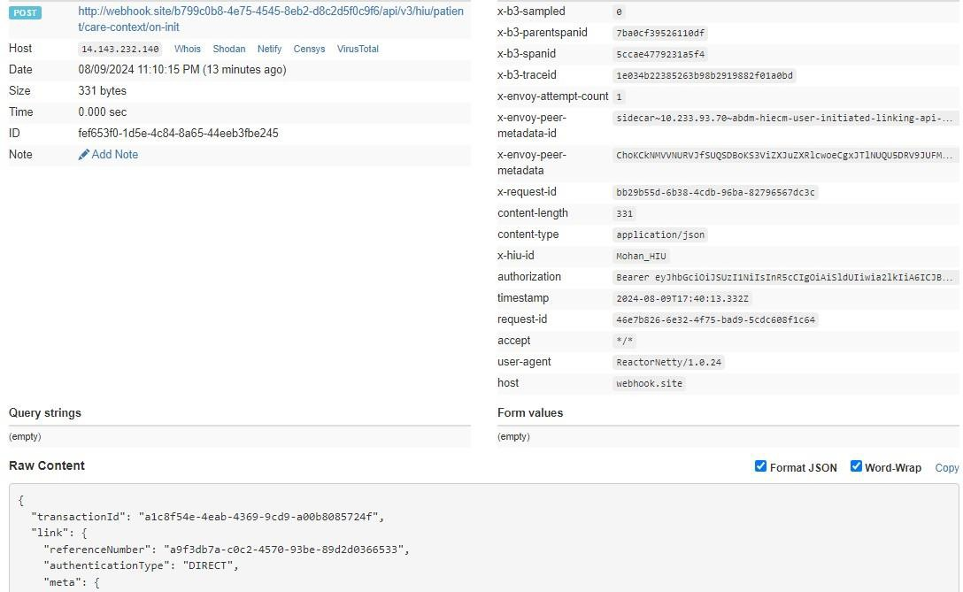

Patient health record confirm

This API will be invoked by the patient to confirm his/her health records.

URL: /api/hiecm/user-initiated-linking/v3/link/care-context/confirm Request: POST

Header Parameters:
Property  Name | Example Value | Required | Description
Authorization | eyJhbGciOiJSUzUxMiJ9. eyJzdWIiOiJ2YXN hbnRoYWt1bWFyLmtlc2F2YW5Ac2J4IiwiY 2xpZW50SWQiOiJzYngiLCJzeXN0ZW0iOiJ  BQkhBLUEiLCJyZXF1ZXN0ZXJJZCI6IlBIUi1XR  UIiLCJwaHJNb2JpbGUiOm51bGwsImV4c CI6MTY2NzI5ODExNSwiaWF0IjoxNjY3Mjkw OTE1LCJwaHJBZGRyZXNzIjoidmFzYW50aG FrdW1hci5rZXNhdmFuQHNieCIsInR4bklkIj oiYjEwMGM4ZDMtNTE1ZC00YWFiLTg1OWQ tYzNlMTUwOTE3ZGY1In0 | Yes | JWT Access token which was issued by ABDM session API after successful validation of client id and secret
REQUEST-ID | 18235d89-cb13-479d-ad71-  7a57d5f669a8 | Yes | Unique UUID for track the end to end request transaction
TIMESTAMP | 2022-10-06T10:10:00.587Z | Yes | Actual time when request was initiated, ISO Date time format represents date and time
X-AUTH-TOKEN | eyJhbGciOiJSUzUxMiJ9.eyJzdWIiOiJ2 YXNhbnRoYWt1bWFyLmtlc2F2 |  | JWT Authentication token which was issued by ABDM after successful validation of username and password
X-HIU-ID | HIU_ID | Yes | Identifier of the health information user by which the request was  initiated
X-CM-ID | sbx | Yes | Suffix of the consent manager to which the request was intended

Body Parameters:
Property Name | Example Value | Required | Description
linkRefNumber | “4336268d-89a3-4c84-  8674aef42092d9fc” | Yes | Link reference number used while initiating the linking of health records of the patient
token | “123456” | Yes | OTP generated during init process to confirm the linking
Request Body:
Request Body

{
"token": 123456,
"linkRefNumber": "4336268d-89a3-4c84-8674-aef42092d9fc" }
Response:
Response
Code : 202 Accepted

Error scenarios:

Scenarios | Headers/Body | Message
To verify when  Request ID is Blank, null or empty in header | [  {  "key": "REQUEST-ID",  "value": "",  "type": "text"  }  ] | Access Denied Code : 403 Forbidden
To verify when invalid Request-ID is pass in header | [  {  "key": "REQUEST-ID",  "value": "{{$guid}}zxzzxs", "type": "text"  }  ] | {  "code": "ABDM-1030: ", "message": "Invalid  request ID"  }  Code: 400Bad Request
When  Timestamp is Blank, null or empty in header. | [  {  "key": "TIMESTAMP",  "value": "",  "type": "text"  }  ] | Access Denied  Code : 403 Forbidden
When invalid Timestamp is pass in header | [  {  "key": "TIMESTAMP",  "value": "{{$isoTimestamp}}jhgftytgtyu", "type": "text"  }  ] | {  "code": "ABDM-1016: ",  "message": "Invalid Timestamp"  }  Code - 400Bad Request

When X-  HIU-ID is Blank, null or empty in header. | [  {  "key": "X-HIU-ID",  "value": "",  "type": "text"  }  ] | Access Denied  Code : 403 Forbidden
When X-CM-ID is Invalid,  Blank, null or  empty in header. | [  {  "key": "X-CM-ID",  "value": "sbxdvdfvdf", "type": "text"  }  ] | Access Denied  Code : 403 Forbidden
When XAuth-TOKEN  is Invalid in header. | [  {  "key": "X-LINK-TOKEN",  "value": "hghhjjkhjkbkjbjkbkjbnkjbk", "type": "text"  }  ] | {  ""code"": ""ABDM-1066: "",  ""message"": ""Invalid JWT token""  }  Code - 400Bad Request"
Verify  message when invalid  token is passed | {  "token": 7897654,  "linkRefNumber": "Testing defect"  } | {  "code": "ABDM-9999: ", "message": Invalid link reference number."  }
Verify  message when the X-HIU-ID is  different from  the hiu that initiated link request. |  | {  "code": "ABDM-1040: ",  "message": “Invalid HIU ID."  }

HIE-CM callback for health record confirmation

This API will be invoked by the HIE-CM to confirm patient health records to HIP

URL: {callback_url}/api/v3/hip/link/care-context/confirm Request: POST
Header Parameters:
Property Name | Example Value | Required | Description
REQUEST-ID | 18235d89-cb13-479d-ad71-  7a57d5f669a8 | Yes | Unique UUID for tracking the end-to-end request transaction

TIMESTAMP | 2022-10-06T10:10:00.587Z | Yes | Actual time when request was initiated, ISO Date time format represents date and time
X-HIU-ID | IN2810014366 | Yes | Identifier of the health information provider to which the request was intended
Body Parameters:
Property Name | Example Value | Required | Description
linkRefNumber | “4336268d-89a3-4c84-8674aef42092d9fc” | Yes | Link reference number used while initiating the linking of health records of the patient
Token | “123456” | Yes | OTP generated during init process to confirm the linking
Request Body:
Request Body:
{
"confirmation": {
"token": "123456",
"linkRefNumber": "4336268d-89a3-4c84-8674-aef42092d9fc"
}
}
Response:
Response
Code : 202 Accepted

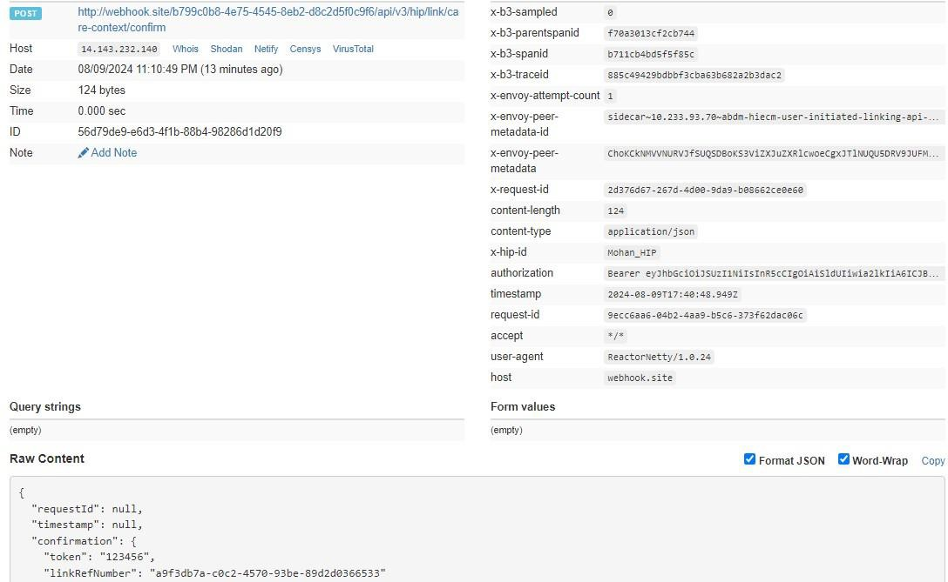

HMIS/LMIS response on health record confirm
This API will be invoked by the HIP to share the response of link confirmation API

URL: /api/hiecm/user-initiated-linking/v3/link/care-context/on-confirm Request: POST
Header Parameters:
Property  Name | Example Value | Required | Description
Authorization | eyJhbGciOiJSUzUxMiJ9. eyJzdWIiOiJ2YXNhb nRoYWt1bWFyLmtlc2F2YW5Ac2J4IiwiY2xpZW 50SWQiOiJzYngiLCJzeXN0ZW0iOiJBQkhBLUEi LCJyZXF1ZXN0ZXJJZCI6IlBIUi1XRUIiLCJwaHJN  b2JpbGUiOm51bGwsImV4cCI6MTY2NzI5ODE xNSwiaWF0IjoxNjY3MjkwOTE1LCJwaHJBZGRy ZXNzIjoidmFzYW50aGFrdW1hci5rZXNhdmFu  QHNieCIsInR4bklkIjoiYjEwMGM4ZDMtNTE1ZC0  0YWFiLTg1OWQtYzNlMTUwOTE3ZGY1In0 | Yes | JWT Access token which was issued by ABDM session API after successful validation of client id and secret
REQUEST-ID | 18235d89-cb13-479d-ad71-7a57d5f669a8 | Yes | Unique UUID for track the end to end request transaction
TIMESTAMP | 2022-10-06T10:10:00.587Z | Yes | Actual time when request was initiated, ISO Date time format represents date and time
X-CM-ID | sbx | Yes | Suffix of the consent manager to which the request was intended
Body Parameters:

Property Name | Example Value | Required | Description
patient | - | Yes | A list of records of the patient that were found as a result of the identifiers that the patient had provided.
referenceNumber | “4336268d-89a34c84-  8674aef42092d9fc” | Yes | Link reference number used while initiating the linking of health records of the patient
Display | Display Text | No | The display text for patient reference
careContexts | - | Yes | List of care contexts linked at the HIP end for the identified patient.
hiType | PRESCRIPTION | Yes | HiType of the patient details
Count | 1 | Yes | The count of care contexts that are found for the patient in scope
requestId | f207e461-1994-42749b86-554384f170ab | Yes | Request ID sent in init API call. This request ID will be used to match the flow of linking care contexts for a patient
Request Body:
Request Body:
{
"patient": [
{
"referenceNumber": "4336268d-89a3-4c84-8674-aef42092d9fc", "display": "abcdefg-display",
"careContexts": [
{
"referenceNumber": "1234", "display": "1234-display"
}
],
"hiType": "PRESCRIPTION",
"count": 1
}
],
"response": {
"requestId": "f207e461-1994-4274-9b86-554384f170ab"
}
}
Response:
Response
Code : 202 Accepted
Error scenarios:

Scenario  s | Request Body | Response

To verify when Request ID is Blank,  null or empty in header | [  {  "key": "REQUEST-ID",  "value": "",  "type": "text"  }  ] | Access Denied  Code : 403 Forbidden
To verify when invalid  Request-ID is pass in header | [  {  "key": "REQUEST-ID",  "value": "{{$guid}}zxzzxs", "type": "text"  }] | {  "code": "ABDM-1030: ",  "message": "Invalid request ID"  }  Code: 400Bad Request
When X-HIP-ID is  Blank, null or empty in header. | [  {  "key": "X-HIP-ID",  "value": "",  "type": "text"  }  ] | Access Denied  Code : 403 Forbidden
When X-CM-ID is  Invalid, Blank, null or empty in header. | [  {  "key": "X-CM-ID",  "value": "sbxdvdfvdf", "type": "text"  }  ] | Access Denied  Code : 403 Forbidden
Verify  message when request id is passed | {  "patient": [  {  "referenceNumber": "Testing defe ct", "display": "bg",  "careContexts": [  {  "referenceNumber": "1234",  "display": "12"  }  ],  "hiType": "PRESCRIPTION",  "count": 1  }  ],  "response": {}  } | {  "code": "ABDM-1015",  "message": "Invalid Response"  }

Verify  message when  count is incorrect | {  "patient": [  {  "referenceNumber": "Testing defe ct", "display": "bg",  "careContexts": [  {  "referenceNumber": "1234",  "display": "12"  }  ],  "hiType": "PRESCRIPTION",  "count": 1  }  ],  "response": {  "requestId": "f9d77c6b-e918-438da19f-835f356c118b"  } | "{  ""code"": ""ABDM-9999: "",  ""message"": ""Invalid Care  Contexts count, must range between 1 to 20""  } "

HIE-CM response on health record on-confirm
This is callback API will be invoked by the HIE-CM to share the response of on-confirm API from HIP.
URL: {callback_url}/api/v3/hiu/patient/care-context/on-confirm
Request: POST

Header Parameters:
Property Name | Example Value | Required | Description
REQUEST-ID | 18235d89-cb13-479d-ad71-  7a57d5f669a8 | Yes | Unique UUID for tracking the end-to-end request transaction
TIMESTAMP | 2022-10-06T10:10:00.587Z | Yes | The actual time when the request was initiated, ISO Date time format represents the date and time
X-HIU-ID | IN2810014366 | Yes | Identifier of the health information provider to which the request was intended
Body Parameters:
Property Name | Example Value | Required | Description
patient | - | Yes | A list of records of the patient that were found as a result of the identifiers that the patient had provided.

referenceNumber | “4336268d-89a34c84-  8674aef42092d9fc” | Yes | Link reference number used while initiating the linking of health records of the patient
careContexts | - | Yes | List of care contexts linked at the HIP end for the identified patient.
hiType | PRESCRIPTION | Yes | HiType of the patient details
Count | 1 | Yes | The count of care contexts that are found for the patient in scope
requestId | f207e461-1994-42749b86-554384f170ab | Yes | Request ID sent in the init API call. This request ID will be used to match the flow of linking care contexts for a patient
Request Body:
Request Body
{
"patient": [
{
"referenceNumber": "4336268d-89a3-4c84-8674-aef42092d9fc", "display": "abcdefg-display",
"careContexts": [
{
"referenceNumber": "1234", "display": "1234-display"
}
],
"hiType": "PRESCRIPTION",
"count": 1
}
],
"response": {
"requestId": "f207e461-1994-4274-9b86-554384f170ab"
}
}

Response:

Response
Code : 202 Accepted

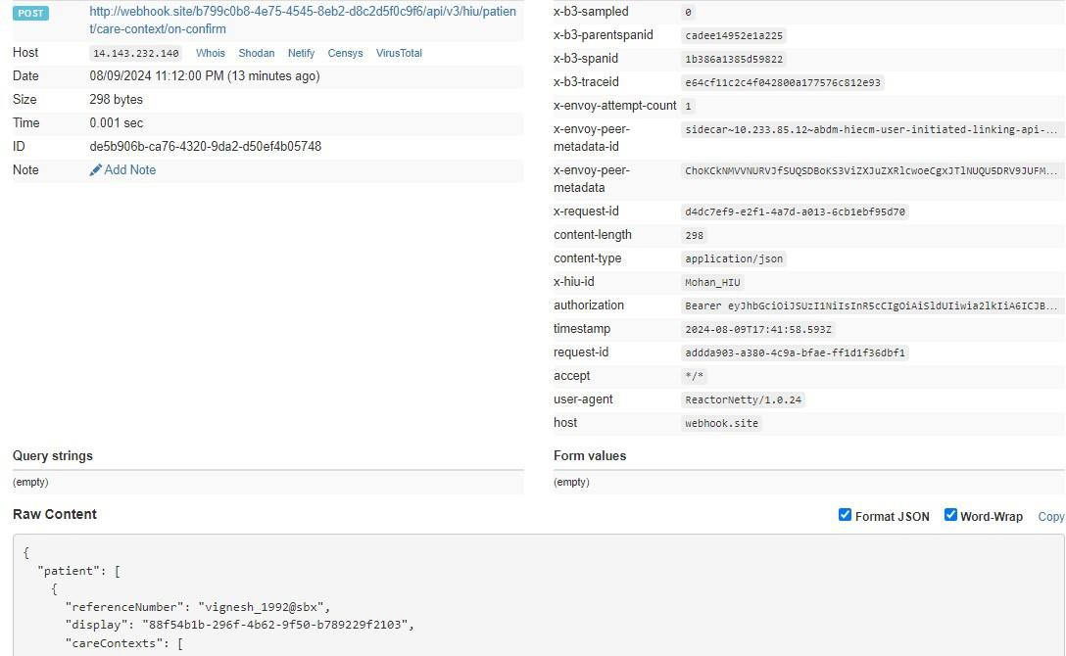

Data Flow

Overview
The process of Data flow starts once the HIECM has generated Consent artefact (Consent artefact is generated only if the status of Consent request is “Granted”) and same is notified to HIP and HIU. HIU sends pushback URL to HIP via HIECM. HIP now bundles the care context or Health data of the patient as per FHIR standards and share the data via pushback data URL. HIECM is notified the status of the data shared both by HIU and HIP.

Sequence Diagram

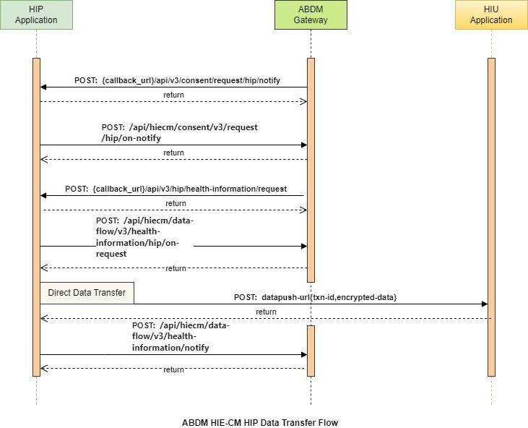

List of APIs

Callback API to HIP when a consent request is APPROVED/REVOKED

This API is a callback to HIP when a consent request is approved/revoked.

URL: {callbackURL}/api/v3/consent/request/hip/notify
Request: POST

Header Parameters:
Property Name | Example Value | Required | Description

REQUEST-ID | 18235d89-cb13-479d-ad71-  7a57d5f669a8 | Yes | Unique UUID for track the end to end request transaction
TIMESTAMP | 2022-10-06T10:10:00.587Z | Yes | Actual time when request was initiated, ISO Date time format represents date and time
X-HIP-ID | eyJhbGciOiJSUzUxMiJ9.eyJzdWIiOiIx  ODQ0MzgxMDgwNjQ0MEBhYmRt | Yes | Identifier to the health information provider.
Body parameters:
Property Name | Example Value | Required | Description
Status | GRANTED | Yes | The status of the consent artefact
consentId | 3fa85f64-5717-4562b3fc-  2c963f66afa6 | Yes | The consent artefact  id
createdAt | 2024-05-  01T05:10:20.123Z | Yes | The date when consent artefact was created.
patient | abc@abdm | Yes | A unique and valid ABHA address suffix with @abdm for live and @sbx for Sandbox
Hip | ABDM_HIP | No | Health information provider ID
purpose – text | Care Management | Yes | Purpose text of consent request
Purpose-code | CAREMGT | Yes | Purpose code of consent request
Purpose-refUri | www.test.com | Yes | Purpose refUri of consent request
patientReference | batman@tmh | No | Patient reference Id
careContextReference | Episode11 | No | Care context reference
Hiu | Sub_HIU | Yes | Health information user Id
Requester-name | Smith | Yes | Name of the requester
Requester-identifiertype | REGN01 | Yes | Requester identifier type
Requester-identifiervalue | MH1001 | Yes | Requester identifier value
Requester-identifiersystem | https://www.mciindia.  org | Yes | Requester identifier system
hiTypes | ["OPCONSULTATION",  "WELLNESSRECORD"] | Yes | Type of document
PermissionaccessMode | VIEW | Yes | Access mode of consent

PermissiondateRange | "from": "2023-0509T08:58:09.738Z", "to": "2023-  0510T08:58:09.738Z" | Yes | Data range of permission required
PermissiondateEraseAt | 2023-05-  25T08:58:09.738Z | Yes | Date of erase data
Permissionfrequency-value | 0 | Yes | Frequency value for consent
Permissionfrequency-repeats | 0 | Yes | Frequency repeats for consent
Permissionfrequency-unit | HOUR | Yes | Frequency unit for consent
Signature | e8nY601CYDsC0FKoDj  Sp+7GeQ2s2R8oZncLC z5ce+pEuDOr5bZV0aa HjwJg4b9S9V+twjt4hb ojx3fl7egrt8+0c+lfPTi5  /bBUAQXCABTfFmtFU7  jn65HlTt8kgkiONx26ZB hJ0wX3xjYI72PPtzYIiT5 Q08YtDoILA62KceioV7l wuKssw7wC4ECbBAvR uXT121TmtrPhf+0myJA TSnaajS06S6OthrKfZLN TUFf3pFiJzqouSTrjNblO X6DT2+JuO3rom1Szz/0 3c0HQG+wWASv+PO3  J6uRs0UI4JvKmM/4tP  +Z+/HPKM15K5U5K+4p  qf6czKrbIDpkT/kP8bG g== | Yes | Signature of signed consent artefact details.
grantAcknowledgeme nt | False | Yes | The Boolean flag to denote if HIP acknowledged the  callback.

Request Body:
Request Body:

{
"notification": { "status": "GRANTED",
"consentId": "3fa85f64-5717-4562-b3fc-2c963f66afa6", "consentDetail": {
"schemaVersion": "v3",
"consentId": "3fa85f64-5717-4562-b3fc-2c963f66afa6", "createdAt": "2024-05-01T05:10:20.123Z",
"patient": {
"id": "abdulkalam@abdm"
},
"careContexts": [
{
"patientReference": "batman@tmh", "careContextReference": "Episode1"
}
],
"purpose": {
"text": "Care Management", "code": "CAREMGT",
"refUri": "www.abc.com"
},
"hip": {
"id": "cowin_hip_01", "name": "Cowin",
"type": "HIP"
},
"hiu": {
"id": "cowin_hiu_01", "name": "Cowin",
"type": "HIU"
},
"consentManager": { "id": "abdm"
},
"requester": {
"name": "abdulkalam@abdm", "identifier": {
"value": "REG1",
"type": "MH1001",
"system": "https://www.sample.com"
}
},
"hiTypes": [
"DiagnosticReport, Prescription, ImmunizationRecord, DischargeSummary, OPConsultation, HealthDocumentRecord, WellnessRecord"
],
"permission": {
"accessMode": "VIEW", "dateRange": {
"from": "2021-09-28T12:30:08.573565Z", "to": "2021-09-28T12:30:08.573565Z"

},
"dataEraseAt": "2021-09-28T12:30:08.573565Z",
"frequency": { "unit": "HOUR",
"value": 1,
"repeats": 0
}
}
},
"signature":
"e8nY601CYDsC0FKoDjSp+7GeQ2s2R8oZncLCz5ce+pEuDOr5bZV0aaHjwJg4b9S9V+twjt4hbojx3fl7e
grt8+0c+lfPTi5/bBUAQXCABTfFmtFU7jn65HlTt8kgkiONx26ZBhJ0wX3xjYI72PPtzYIiT5Q08YtDoILA62Kce ioV7lwuKssw7wC4ECbBAvRuXT121TmtrPhf+0myJATSnaajS06S6OthrKfZLNTUFf3pFiJzqouSTrjNblOX6D
T2+JuO3rom1Szz/03c0HQG+wWASv+PO3J6uRs0UI4JvKmM/4tP+Z+/HPKM15K5U5K+4pqf6czKrbIDpk T/kP8bGg==", "grantAcknowledgement": false
}
}

Response Body:
Response
Status: 202 Accepted

HIP to respond back to consent HIP notify

This API will be invoked by HIP to respond back to the callback API

URL: /api/hiecm/consent/v3/request/hip/on-notify
Request: POST

Header Parameters:
Property Name | Example Value | Required | Description
REQUEST-ID | 18235d89-cb13-479d-ad71-  7a57d5f669a8 | Yes | Unique UUID for track the end to end request transaction

TIMESTAMP | 2022-10-06T10:10:00.587Z | Yes | Actual time when request was initiated, ISO Date time format represents date and time
X-CM-ID | sbx | Yes | Suffix of the consent manager to which the request was intended
Body parameters:
Property Name | Example Value | Required | Description
Status | OK | Yes | The status of the consent notify.
consentId | 3fa85f64-5717-4562b3fc-  2c963f66afa6 | Yes | The consent artefact  id
Error | "error": {  "code": "ABDM-1001",  "message": "unable to connect database"  } | No | The error code and  message if any happened.
requestId | 3fa85f64-5717-4562b3fc-  2c963f66afa6 | Yes | The request id from the  /consent/hip/notify
Request Body:
Request Body:
{
"acknowledgement": { "status": "OK",
"consentId": "e3c74829-3f82-4f94-959e-e10f57bcd57b"
},
"error": {
"code": "ABDM-1001",
"message": "unable to connect database"
},
"response": {
"requestId": "6f0b4665-a915-4c92-aa36-65afb4a2cd71"
}
}

Response Body:
Response
Status: 202 Accepted

Data Flow - Health information request – Callback to HIP

This isa callback API triggered by HIE-CM to notify HIP about the health information request.

URL: {callback_URL}/api/v3/hip/health-information/request Request: POST
Header Parameters:
Property Name | Example Value | Required | Description
Authorization | eyJhbGciOiJSUzUxMiJ9. eyJzdWIiOiJ2YXNhbnRoY Wt1bWFyLmtlc2F2YW5Ac 2J4IiwiY2xpZW50SWQiOi JzYngiLCJzeXN0ZW0iOiJ  BQkhBLUEiLCJyZXF1ZXN0Z XJJZCI6IlBIUi1XRUIiLCJwa  HJNb2JpbGUiOm51bGws ImV4cCI6MTY2NzI5ODEx  NSwiaWF0IjoxNjY3MjkwO TE1LCJwaHJBZGRyZXNzIjo  idmFzYW50aGFrdW1hci5 rZXNhdmFuQHNieCIsInR 4bklkIjoiYjEwMGM4ZDMt NTE1ZC00YWFiLTg1OWQtY zNlMTUwOTE3ZGY1In0 | Yes | JWT Access token which was issued by ABDM session API after successful validation of client id and secret.
REQUEST-ID | 18235d89-cb13-479dad71-  7a57d5f669a8 | Yes | Unique UUID for tracking the end-to-end request  transaction
TIMESTAMP | 2022-10-  06T10:10:00.587Z | Yes | The actual time when the request was initiated, ISO Date time format represents the date and time
X-HIP-ID | IN2810014366 | Yes | Identifier to the health information provider.
Body Parameters:
Property  Name | Example Value | Required | Description
Consent ID | 18235d89-cb13-479d-ad71-7a57d5f669a8 | Yes | Valid consent ID, which HIU must obtain to request patient data  from a HIP
DateRange | [  {  "from": "1924-07-09T12:05:57.151Z",  "to": "2024-07-17T12:05:57.151Z"  }  ] | Yes | Date Range against which the consent granted will be  validated.

DataPushUrl | https://webhook.site/2cfcc184-5d29-4e2c974d-3e56cbaa5cc1/v3/data/push | Yes | This is the URL provided by HIU to which HIP has to push the requested health information record
cryptoAlg | “ECDH” |  | ECDH is a key sharing algorithm, most commonly used to send encrypted messages. ECDH works by multiplying your private key by another's public key to get a shared secret, then using that shared secret to  perform symmetric encryption
curve | “curve25519” | Yes | Key exchanges authentication
expiry | 2124-12-09T00:00:00.000Z | Yes | Actual time by when dataPushUrl is  available
parameters | “Ephemeral public key” | Yes | Encryption and decryption key
keyValue | BFN7KTdOT0jIAExG2A8Jg+01w  MPWxptiGqwHRVvtiVEsUq2FR7P2  UdqZxJyPJSeR6muai21iQhasNxnhh8I5M+g=" | Yes | key agreement protocol that allows two parties, each
having an ellipticcurve public– private key
pair, to establish a shared secret over an insecure channel
Request Body:
Request Body

{
"hiRequest": {
"consent": {
"id": "d6a83f24-6c96-421e-b8b8-844e5344ef69"
},
"dateRange": {
"from": "1924-07-09T12:05:57.151Z",
"to": "2024-07-17T12:05:57.151Z"
},
"dataPushUrl": "https://webhook.site/2cfcc184-5d29-4e2c-974d3e56cbaa5cc1/v3/data/push", "keyMaterial": {
"cryptoAlg": "ECDH", "curve": "Curve25519", "dhPublicKey": {
"expiry": "2124-12-09T00:00:00.000Z",
"parameters": "Curve25519/32byte random key", "keyValue":
"BCpsBW37KgfLyjxJK0zHHG26hDjxzK368DEO4PapzFhQM0cghZziKuvJh5/anTnHitVHKMn0Owr1HvcH1f m0DpA="
},
"nonce": "0ka0stPfqmXWhX+ODC/iOFMO0PXFdRjBdcEGbv55qqc="
}
}
}

Response:

Response
Code : 202 Accepted

HIP acknowledgement to the health information request

This API will be invoked by HIP to acknowledge the health information request by HIU.

URL: /api/hiecm/data-flow/v3/health-information/hip/on-request Request: POST
Header Parameters:
Property Name | Example Value | Required | Description

Authorization | eyJhbGciOiJSUzUxMiJ9. eyJzdWIiOiJ2YXNhbnRoY Wt1bWFyLmtlc2F2YW5Ac 2J4IiwiY2xpZW50SWQiOi JzYngiLCJzeXN0ZW0iOiJ  BQkhBLUEiLCJyZXF1ZXN0Z XJJZCI6IlBIUi1XRUIiLCJwa  HJNb2JpbGUiOm51bGws ImV4cCI6MTY2NzI5ODEx  NSwiaWF0IjoxNjY3MjkwO TE1LCJwaHJBZGRyZXNzIjo  idmFzYW50aGFrdW1hci5 rZXNhdmFuQHNieCIsInR 4bklkIjoiYjEwMGM4ZDMt NTE1ZC00YWFiLTg1OWQtY zNlMTUwOTE3ZGY1In0 | Yes | JWT Access token which was issued by ABDM session API after successful validation of client id and secret.
REQUEST-ID | 18235d89-cb13-479dad71-  7a57d5f669a8 | Yes | Unique UUID for tracking the end-toend request  transaction
TIMESTAMP | 2022-10-  06T10:10:00.587Z | Yes | The actual time when the request was initiated, ISO Date time format represents the date and time
X-CM-ID | IN2810014366 | Yes | Suffix of the consent manager to which the request was intended.
Body Parameters:
Property Name | Example Value | Required | Description
transactionId | 18235d89-cb13-479dad71-  7a57d5f669a8 | No | Unique transaction id to track the health information request
sessionStatus | ACKNOWLEDGED | No | Status of the request
Error |  | No | Error code and message if any occurred
requestId | 18235d89-cb13-479dad71-  7a57d5f669a8 | Yes | Unique id to track end to end transaction
Request Body:
Request Body

{
"hiRequest": {
"transactionId": "18235d89-cb13-479d-ad71-7a57d5f669a8", "sessionStatus": "ACKNOWLEDGED"
},
"response": {
"requestId": "18235d89-cb13-479d-ad71-7a57d5f669a8 “
}
}
Response:

Response
Code : 202 Accepted

    - HIP calling data push URL
This API will be invoked by HIP to push the data to HIU.

URL: /api-hiu/data/notification Request: POST

Body Parameters:
Property Name | Example Value | Required | Description
pageNumber | 1 | Yes | The page number
pageCount | 2 | Yes | The total page count
transactionId | 18235d89-cb13-479dad71-  7a57d5f669a8 | Yes | The transaction id that is generated when health information request initiated.
entries | "entries": [  {"content": "{{content}}", "media":  "application/fhir+json", | Yes | List of encrypted content details.
"checksum": "{{checksum}}",

"careContextReference": "{{care Context Reference}}"

}

]

keyMaterial | "keyMaterial": {  "cryptoAlg": "ECDH", "curve":  "Curve25519",  "dhPublicKey": {  "expiry": "{{expiry date}}",  "parameters": "Curve25519/32byte random key",  "keyValue": "{{Key value}}"  },  "nonce": "{{nonce}}"  } | Yes | Encryption/Decryption key details
Request Body:
Request Body
{
"pageNumber": 0,
"pageCount": 1,
"transactionId": "{{transactionId}}", "entries": [
{"content": "{{content}}",
"media": "application/fhir+json", "checksum": "{{checksum}}",
"careContextReference": "{{care Context Reference}}"
}
],
"keyMaterial": {
"cryptoAlg": "ECDH",
"curve": "Curve25519", "dhPublicKey": {
"expiry": "{{expiry date}}",
"parameters": "Curve25519/32byte random key", "keyValue": "{{Key value}}"
},
"nonce": "{{nonce}}"
}
}

Response:

Response
Code : 202 Accepted

    - Health Information notify API

This API will be called by HIU and HIP to notify the CM about the status of the data transfer.

HIP on the transfer of data would send sessionStatus - one of [TRANSFERRED, FAILED]. HIP would also send hiStatus for each careContextReference - on of [DELIVERED, ERRORED]

HIU on receipt of data would send sessionStatus - one of [RECEIVED, FAILED]. For example, ERRORED when data was not sent or if invalid data was sent. HIU would also send hiStatus for each careContextReference - one of [OK, ERRORED].
.URL: /api/hiecm/data-flow/v3/health-information/notify

Request: POST

Header Parameters:
Property Name | Example Value | Required | Description
Authorization | eyJhbGciOiJSUzUxMiJ9. eyJzdWIiOiJ2YXNhbnRoY Wt1bWFyLmtlc2F2YW5Ac 2J4IiwiY2xpZW50SWQiOi JzYngiLCJzeXN0ZW0iOiJ  BQkhBLUEiLCJyZXF1ZXN0Z XJJZCI6IlBIUi1XRUIiLCJwa  HJNb2JpbGUiOm51bGws ImV4cCI6MTY2NzI5ODEx  NSwiaWF0IjoxNjY3MjkwO TE1LCJwaHJBZGRyZXNzIjo  idmFzYW50aGFrdW1hci5 rZXNhdmFuQHNieCIsInR 4bklkIjoiYjEwMGM4ZDMt NTE1ZC00YWFiLTg1OWQtY zNlMTUwOTE3ZGY1In0 | Yes | JWT Access token which was issued by ABDM session API after successful validation of client id and secret.

REQUEST-ID | 18235d89-cb13-479dad71-  7a57d5f669a8 | Yes | Unique UUID for tracking the end-toend request  transaction
TIMESTAMP | 2022-10-  06T10:10:00.587Z | Yes | The actual time when the request was initiated, ISO Date time format represents the date and time
X-CM-ID | IN2810014366 | Yes | Suffix of the consent manager to which the request was intended.
Body Parameters:
Property Name | Example Value | Required | Description
consentId | 97c3668e-49e3-4121b2d3-  1ca6d949cd8a | Yes | The consent artefact  id
transactionId | e3472dad-86c5-42df9afd-d7c13df2a564 | Yes | The transaction id that is generated when health information request initiated.
doneAt | 2023-05-  24T10:51:08.374Z | Yes | UTC date when the data was transferred/received.
notifier | "notifier": { | Yes | Identifier to denote either HIP or HIU is calling this API
"type": "HIP",

"id": "HIP-HOSPITAL"

}

statusNotification | "statusNotification": {  "sessionStatus": "TRANSFERRED",  "hipId": "HIP-HOSPITAL",  "statusResponses"  : [  {  "careContextR eference": "b18d2e56c5d2-41d0-bbe932a8b7579f74",  "hiStatus": "OK",  "description": "test care context"  }  ]  } | Yes | Status of the data transfer
Request Body:
Request Body
{
"notification": {
"consentId": "97c3668e-49e3-4121-b2d3-1ca6d949cd8a",
"transactionId": "e3472dad-86c5-42df-9afd-d7c13df2a564", "doneAt": "2023-05-24T10:51:08.374Z",
"notifier": { "type": "HIP",
"id": "HIP-HOSPITAL"
},
"statusNotification": { "sessionStatus": "TRANSFERRED", "hipId": "HIP-HOSPITAL",
"statusResponses": [
{
"careContextReference": "b18d2e56-c5d2-41d0-bbe9-32a8b7579f74", "hiStatus": "OK",
"description": "test care context"
}
]
}

}
}

Response:

Response
Code : 202 Accepted
{
“status”: “Notification is Accepted”
}

Scan and Profile Share

Overview

The User/Patient can share his/her basic KYC information with the
HMIS/LIMS by scanning the QR Code using the integrator application (Example: ABHA App), which enables them to complete the seamless profile share during their visit.
The authenticity of the profile information is verified by the HIE-CM internally before sharing with the HMIS/LIMS.

The content of the QR code is a URL (sample for reference: https://phrsbx.abdm.gov.in/share-profile?hipid=IN3410000260&counter-id=12345) that contains 2 parameters:
- The HIP ID
- Facility defined context (for example: counter code)

Sequence Diagram
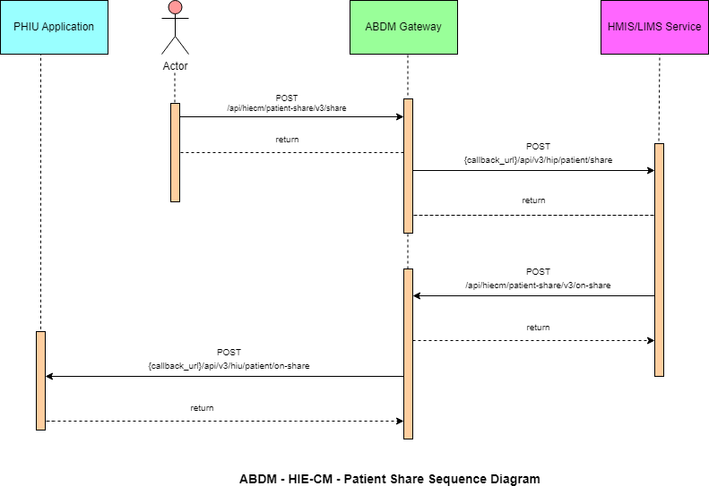

List of APIs

Profile share

This API will be invoked from the integrator application (any PHR application, just like ABHA) to share the user/patient profile with HMIS/LIMS.

URL: /api/hiecm/patient-share/v3/share
Method: POST

Request Headers:

Property Name | Example Value | Require d | Descriptio n
REQUEST-ID | 18235d89-cb13-479d-ad71-  7a57d5f669a8 | Yes | Unique UUID for track the end to end request  transaction
TIMESTAMP | 2022-10-06T10:10:00.587Z | Yes | Actual time when request was initiated, ISO Date time format represents  date and time
Authorizatio n | eyJhbGciOiJSUzUxMiJ9. eyJzdWIiOiJ2YXNhbnRoYWt1bWFyLmtlc 2F2  YW5Ac2J4IiwiY2xpZW50SWQiOiJz YngiLCJzeXN0ZW0iOiJBQkhBLUEiLCJy ZXF1ZXN0ZXJJZCI6IlBIUi1XRUIiL  CJwaHJNb2JpbGUiOm51bGwsImV4c CI6MTY2NzI5ODExNSwia  WF0IjoxNjY3MjkwOTE1LCJwaHJBZ  GRyZXNzIjoidmFzYW50aGFrdW1hci5rZX NhdmFuQHNieCIsInR4bklkIjoi  YjEwMGM4ZDMtNTE1ZC00YWFiLTg1O WQtYzNlMTUwOTE3ZGY1In0 | Yes | JWT Access token which was issued  by ABDM session API after successful validation of client id and secret
X-HIU-ID | IN2810014366 | Yes | Identifier of the health information user to which the request was intended
X-CM-ID | sbx | Yes | Suffix of the consent manager to which the request was  intended

X-AUTH-TOKEN | eyJhbGciOiJSUzUxMiJ9.eyJzdWIiOiJna XJpamFAc2J4IiwiY2xpZW50SWQiOiJQS FItV0VCIiwicmVxdWVzdGVySWQiOiJrX 2hpcCIsInN5c3RlbSI6IkFCRE0iLCJtb2Jp bGUiOiI4MjgxMTQ3MDgwIiwiZXhwIjoxNj  c3NjY5NDU1LCJpYXQiOjE2Nzc2NjIyNTUs  InRyYW5zYWN0aW9uSWQiOiJkMmY5O TNkNi1kODg4LTQyMTMtOTc3My0wYmJj MzMwMjVhNGYiLCJhYmhhQWRkcmVzc  yI6ImdpcmlqYUBzYngifQ.Ad_jGrduH6 _krBBnlRO912mQabxMOiB0GN6FjdZjoi CQY4AkUD3McGq2NR-XGAjHVpkRtKx69m4_44h-  FqTCbZlo09hq0SEM1KBMkPDl163JcFNM JGnXBa5E-mu6DpBSPA-  VirSvBVj6CEpZLbTa2nBBSJJi_leszwHNr  kdope6rSc2G3SJfCW_DzFmzd_fxdvbFCN1yyhN3Rw5r8A1GnSrVSBhRjm4qy5O  _ gutl1XW9CaBaZSah7GOxGRr4gpSIJJvIL WovwG58DyNzEhrHtAfIje_pegqRsNMO FI-  xPYJd2x6CcDKSoAXvXO0jbuoOvlPl5kh plOKU-WcFeWA | Yes | JWT Access token which was issued by IDP service after successfully user  authenticatio n

Body Parameters:

Property  Name | Example Value | Require d | Description
intent | "PROFILE_SHARE" | Yes | This is a key value pair which contains the purpose with following possible values.  Profile_share Payment  Health_record_sharing
metaData | {  "hipId": "Test_HIP", "context": "ABC123", "hprId":  "abdulkalam@abdm", "latitude": "-38.679",  "longitude": "58.498" } | Yes | This is a key value pair which contains the location longitude and latitude
profile | {  "patient": {  "abhaNumber": 18443810806111,  "abhaAddress":  "1844381@abdm", | Yes | This is key value pair which contains patient details

"name": "User 1",
"gender": "M",
"dayOfBirth": "20",
"monthOfBirth": "1",
"yearOfBirth": "1999", "address": {
"line": "C/O Sandipan Kshirsagar Ambejogai Road Renuka Nagar Latur",
"district": null, "state": null, "pincode": null
}

"phoneNumber": "9876543210"
}
}
Request Body

Request Body:
{
"intent": "PROFILE_SHARE",
"metaData": {
"hipId": "MAYUR_HIP",
"context": "ABC123",
"hprId": "abdulkalam@abdm", "latitude": "-38.679",
"longitude": "58.498"
},
"profile": {
"patient": {
"abhaNumber": 91178386101251, "abhaAddress": "9117838@sbx", "name": "User 1",
"gender": "M",
"dayOfBirth": "10",
"monthOfBirth": "10",
"yearOfBirth": "1994", "address": {
"line": "C/O Sandipan Kshirsagar Ambejogai Road Renuka Nagar", "district": null,
"state": null, "pincode": null
},
"phoneNumber": "9876543210"
}
}
}

Response
Response:
Code: 202 ACCEPTED

Profile share – Callback

This is a callback API for patient share API.

URL: {callback_url}/api/v3/hip/patient/share Method:
Post Request Headers:

Property  Name | Example Value | Required | Description
REQUEST-ID | 18235d89-cb13-  479d-ad717a57d5f669a8 | Yes | Unique UUID for track the end to end request transaction
TIMESTAMP | 2022-10-  06T10:10:00.587Z | Yes | Actual time when request was initiated, ISO 8601 represents date and time by starting with the year, followed by the month, the day, the hour, the minutes, seconds and milliseconds
X-HIP-ID | IN2810014366 | Yes | Identifier of the health information provider to which the request was intended

Body parameters

Property Name | Example Value | Required | Description
intent | PROFILE_SHARE | Yes | This is a key value pair which contains the purpose with following possible values.  Profile_share Payment  Health_record_sharing
metaData | "metaData": {  "hipId": "MAYUR_HIP",  "context": "ABC123", | Yes | This is a key value pair which contains the location longitude and latitude

"hprId": "abdulkalam@abdm",
"latitude": "-38.679",
"longitude": "58.498"

}
profile | "profile": { | Yes | This is key value pair which contains
 | "patient": { |  | all the patient details
 | "abhaNumber":
 | 91178386176531,
 | "abhaAddress":
 | "91178386@sbx",
 | "name": "User 1",
 | "gender": "M",
 | "dayOfBirth": "10",
 | "monthOfBirth": "10",
 | "yearOfBirth": "1994",
 | "address": {
 | "line": "C/O Sandipan
 | Kshirsagar Ambejogai Road",
 | "district": null,
 | "state": null,
 | "pincode": null
 | },
 | "phoneNumber":
 | "9876543210"
 | }

Request Body

Request Body:
{
"intent": "PROFILE_SHARE",
"metaData": {
"hipId": "MAYUR_HIP",
"context": "ABC123",
"hprId": "abdulkalam@abdm", "latitude": "-38.679",
"longitude": "58.498"
},
"profile": {
"patient": {
"abhaNumber": 9117838615XXXX, "abhaAddress": "91178XXXX@sbx", "name": "User 1",
"gender": "M",
"dayOfBirth": "XX", "monthOfBirth": "XX", "yearOfBirth": "XXXX", "address": {

"line": "C/O Sandipan Kshirsagar Ambejogai Road Renuka Nagar", "district": null,
"state": null, "pincode": null
},
"phoneNumber": "987654XXXX"
}
} }

Response

Response:
Response: In call back url below details should be displayed as per the Xauth token

{"intent":"PROFILE_SHARE","metaData":{"hipId":"MAYUR_HIP","context":"6","hprId":"abdulkal am@hpr.abdm","latitude":"-
38.670","longitude":"58.498"},"profile":{"patient":{"abhaNumber":"91178386156891","abhaAddr ess":"911783XX@sbx","name":"User 1",
"gender":"M","dayOfBirth":"XX","monthOfBirth":"XX","yearOfBirth":"XXXX","address":{"line":null
,"district":null,"state":null,"pincode":null},"phoneNumber":"987654XXXX"}}}
Code: 200 OK
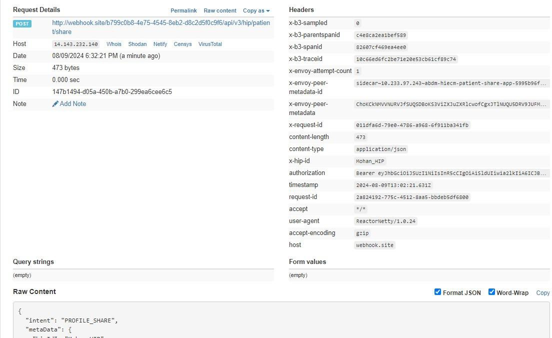

Profile on-share
This API will be invoked by HIP to acknowledge the request by the user/patient to share the profile details.

URL: /api/hiecm/patient-share/v3/on-share
Method: Post

Request Headers:

Property  Name | Example Value | Required | Description
REQUEST-ID | 18235d89-cb13-479d-ad71-  7a57d5f669a8 | Yes | Unique UUID for track the end to end request transaction
TIMESTAMP | 2022-10-06T10:10:00.587Z | Yes | Actual time when request was initiated, ISO 8601 represents date and time by starting with the year, followed by the month, the day, the hour, the minutes, seconds and  milliseconds
Authorization | eyJhbGciOiJSUzUxMiJ9.  eyJzdWIiOiJ2YXNhbnRoYWt1bWFyLmtlc 2F2  YW5Ac2J4IiwiY2xpZW50SWQiOiJz YngiLCJzeXN0ZW0iOiJBQkhBLUEiLCJy ZXF1ZXN0ZXJJZCI6IlBIUi1XRUIiL  CJwaHJNb2JpbGUiOm51bGwsImV4c CI6MTY2NzI5ODExNSwia  WF0IjoxNjY3MjkwOTE1LCJwaHJBZ  GRyZXNzIjoidmFzYW50aGFrdW1hci5rZX NhdmFuQHNieCIsInR4bklkIjoi  YjEwMGM4ZDMtNTE1ZC00YWFiLTg1O  WQtYzNlMTUwOTE3ZGY1In0 | Yes | JWT Access token which was issued by ABDM session API after successful validation of client id and secret
X-CM-ID | sbx | Yes | Suffix of the consent manager to which the request was intended
Body Parameters

Property  Name | Example Value | Required | Description
abhaAddress | ABHA address | Yes | Patient ABHA address against which the health records needs to be linked
status | “SUCCESS” | Yes | Transaction status from HIP to HIECM,  “success” “failed”
context | 43 | Yes | HMIS/LMIS Counter ID
tokenNumber | 3 | Yes | Token number at HMIS/LMIS to be provided to the patient
expiry | 180 | Yes | Patient year of birth
requestId | f29f0e59-8388-46989fe6-  05db67aeac46 | Yes | This is a key value pair which contains the purpose

Request Body

Request Body:
{
"acknowledgement": {
"abhaAddress": "abc@abdm", "status": "success",
"profile": {
"context": "43",
"tokenNumber": "3",
"expiry": "180"
}
},
"response": {
"requestId": "f29f0e59-8388-4698-9fe6-05db67aeac46"
}
}

Response

Response:
Code : 200 OK

Request Body : ERROR
-> Use this in case of error response (Ex: This is the one example for error payload and the code will be same. But, message will be change each error).

Request Body:
{
"error": {
"code": "ABDM-9999: ",
"message": "string
},
"response": {
"requestId": "6f0b4665-a915-4c92-aa36-65afb4a2cd71"
}
}

Profile on share – Callback

This is a callback API for patient on-share API.

URL: {callback_url}/api/v3/hiu/patient/on-share Method:
Post Request Headers:

Property  Name | Example Value | Required | Description
REQUEST-ID | 18235d89-cb13-  479d-ad717a57d5f669a8 | Yes | Unique UUID for track the end to end request transaction
TIMESTAMP | 2022-10-  06T10:10:00.587Z | Yes | Actual time when request was initiated, ISO 8601 represents date and time by starting with the year, followed by the month, the day, the hour, the minutes, seconds and milliseconds
X-HIU-ID | ABDM_sbx | Yes | Suffix of the HIU to which the request was intended
Body Parameters:

Property Name | Example Value | Required | Description
abhaAddress | ABHA address | Yes | Patient ABHA address against which the health records needs to be linked
Status | “success” | Yes | Trasaction status from HIP to HIE-CM,  “success” “failed”
Context | 43 | Yes | HMIS/LMIS Counter ID
tokenNumber | 3 | Yes | Token number at HMIS/LMIS to be provided to the patient
Expiry | 180 | Yes | Patient year of birth

requestId | f29f0e59-8388-4698-  9fe605db67aeac46 | Yes | This is a key value pair which contains the purpose

Request Body

Request Body:
{
"acknowledgement": {
"abhaAddress": "abc@abdm", "status": "success",
"context": "43",
"tokenNumber": "3",
"expiry": 180
},
"response": {
"requestId": "f29f0e59-8388-4698-9fe6-05db67aeac46"
}
}

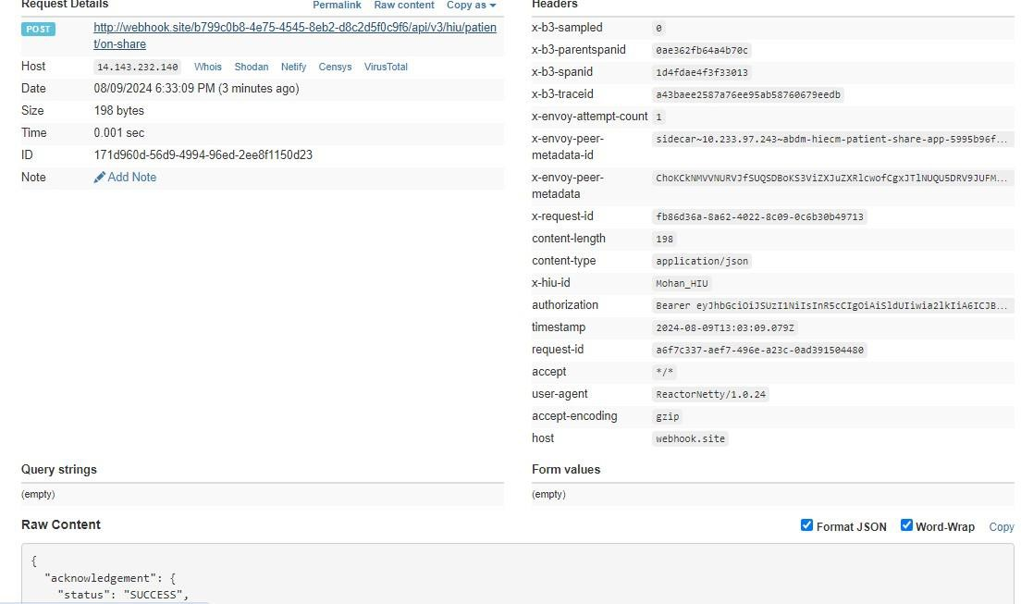
Response

Response:
Code: 200 OK

API Listing

No. | Flow | Serial | v3 API | Description
1 | HIP initiated linking | 1.1 | /api/hiecm/v3/token/gene rate-token | This generic API endpoint will be used to generate a linking token to link care context.
 |  | 1.2 | {callback_url}/api/v3/hip/token/on-generate-token | This is a Call-back API for hiecm/api/v3 /token/generatetoken
 |  | 1.3 | /api/hiecm/hip/v3/link/car econtext | This API needs to be called by the HIP to link the care context against the patient ABHA address, once the HIP has the valid linking token generated against the same patient ABHA address.
 |  | 1.4 | {callback_url}/api/v3/link/ on_carecontext | This is a Call-back API for hiecm/api/v3 /link/carecontext
 |  | 1.5 | /api/hiecm/hip/v3/link/pat ient/links | This API will be invoked to get all the linked health records of the patient.
 |  | 1.6 | /api/hiecm/hip/v3/link/co ntext/notify | This API will be invoked by HIP after updating a health record to notify all the subscribed HIUs.
 |  | 1.7 | {callbackURL}/api/v3/links/ context/on-notify | This is a callback api for  /hiecm/api/v3/link/context/notify API.
 |  | 1.8 | /api/hiecm/hip/v3/link/pat ient/links/sms/notify2 | This API will be invoked by HIP to trigger a SMS notification to the patient mobile number.
 |  | 1.9 | {callbackURL}/api/v3/patie nts/sms/on-notify | This is a callback API for  /hiecm/api/v3/link/patient/links/ sms/notify2 API call.
 |  | 1.10 | /api/hiecm/hip/v3/link/pat ient/links/hip/ondeactivate | This API will be invoked by HIP as a response on deactivating an abha address.
 |  | 1.11 | /api/hiecm/hip/v3/link/pat ient/links/hiu/ondeactivate | This API will be invoked by HIU as a response on deactivating an abha address.
2 | User initiated  linking | 2.1 | /api/hiecm/userinitiated-  linking/v3/patient/carecontext/discover | This API will be invoked by the patient/user from the PHR application to discover his/her health records.
 |  | 2.2 | {callback_url}/api/v3/hi  p/patient/carecontext/discover | This API will be invoked by the HIE-CM to discover patient health records from  HIP.

 |  | 2.3 | /api/hiecm/userinitiatedlinking/v3/patient/carecontext/on-discover | This API will be invoked by the HMIS/LIMS  application for  sharing the response of the discover API.
 |  | 2.4 | {callback_url}/api/v3/hi u/patient/carecontext/on-discover | This API will be invoked by the HIE-CM for sharing the response of the  discover API.
 |  | 2.5 | /api/hiecm/userinitiated-  linking/v3/link/carecontext/init | This is an API that will be invoked by the  patient/user to link his/her  health  records.
 |  | 2.6 | {callback_url}/api/v3/hi p/link/care-context/init | This API will be invoked by the HIE-  CM to link  patient/user health records to HIP.
 |  | 2.7 | /api/hiecm/userinitiatedlinking/v3/link/carecontext/on-init | This is an API that will be invoked by the HIP to share the response  of the init API.
 |  | 2.8 | {callback_url}/api/v3/hi u/patient/carecontext/on-init | This is an API that will be invoked by the  HIE-CM to share the response of the init  API with the Patient.
 |  | 2.9 | /api/hiecm/userinitiatedlinking/v3/link/carecontext/confirm | This API will be invoked by the patient/user to confirm his/her health records.
 |  | 2.10 | {callback_url}/api/v3/hi p/link/carecontext/confirm | This API will be invoked by the HIE-  CM to confirm  patient/user health records to HIP.
 |  | 2.11 | /api/hiecm/userinitiatedlinking/v3/link/carecontext/on-confirm | This is an API that will be invoked by the HIP to share the response of the confirmed  API.

 |  | 2.12 | {callback_url}/api/v3/hi u/patient/carecontext/on-confirm | This API will be invoked by the HIE-CM to share the response of confirm  API to the patient.
3 | Patient Share | 3.1 | /api/hiecm/patientshare/v3/share | This API will be invoked from the integrator application (any PHR application, just like  ABHA) to share the user/patient profile  with HMIS/LIMS.
 |  | 3.2 | {callback_url}/api/v3/hi p/patient/share | Callback API for patient share
 |  | 3.3 | /api/hiecm/patientshare/v3/on-share | This API will be invoked by HIP to acknowledge the request by the  user/patient to share  the profile details.
 |  | 3.4 | {callback_url}/api/v3/hi u/patient/on-share | Callback for Patient on-share
4 | Session | 4.1 | /api/hiecm/gateway/v3  /sessions | API to generate Auth token
5 | Gateway | 5.1 | /api/hiecm/gateway/v3  /bridge/url | API to update the bridge URL
 |  | 5.2 | /api/hiecm/gateway/v3  /certs | API to get keys from keycloak
 |  | 5.3 | /api/hiecm/gateway/v3 /.well-known/openidconfiguration | API to get OpenID configuration
 |  | 5.4 | /api/hiecm/gateway/v3  /bridge-  service/serviceId/{servic eId} | API to fetch bridge details by service id
 |  | 5.5 | /api/hiecm/gateway/v3  /bridge-services | API to fetch all the  service details from a bridge
6 | Data Flow | 6.1 | /api/hiecm/consent/v3/ request/hip/on-notify | API will be called by HIP to acknowledge the consent approval
 |  | 6.2 | /api/hiecm/dataflow/v3/healthinformation/hip/onrequest | API will be called by HIP to acknowledge data flow  request

 |  | 6.3 | /api-  hiu/data/notification | Data transfer API to push data
 |  | 6.4 | /api/hiecm/dataflow/v3/healthinformation/notify | API called by HIP/HIU  to notify the status of data transfer

Error Codes Listing
Code | Error
ABDM-1000 | Unable to connect the database
ABDM-1001 | No data found
ABDM-1002 | Integrity violation
ABDM-1003 | Email Gateway is unavailable
ABDM-1004 | SMS Gateway is unavailable
ABDM-1005 | Invalid receiver

ABDM-1006 | Bad Request, invalid request Body
ABDM-1007 | Connection failed due to timeout
ABDM-1008 | SMS service currently disabled
ABDM-1009 | Email service currently disabled
ABDM-1010 | Validation failed
ABDM-1011 | Gateway database unavailable
ABDM-1012 | No records found against the ABHA Address
ABDM-1013 | Invalid ABHA Number
ABDM-1014 | Invalid Mobile Email
ABDM-1015 | Invalid Response
ABDM-1016 | Invalid TimeStamp
ABDM-1017 | Invalid TransactionId
ABDM-1018 | Share Profile database unavailable
ABDM-1019 | Dependent Service Unavailable
ABDM-1020 | Unknown database
ABDM-1021 | Lack of required priviledges
ABDM-1022 | Too many requests
ABDM-1023 | Invalid User
ABDM-1024 | Dependent service unavailable
ABDM-1025 | Invalid ServiceId
ABDM-1026 | Invalid Link Token
ABDM-1027 | You are blocked. Please try again after 24 hours.
ABDM-1028 | HIP is unavailable
ABDM-1029 | Redis server is unavailable
ABDM-1030 | Invalid request ID
ABDM-1031 | Invalid request
ABDM-1032 | Invalid header
ABDM-1033 | HIU is unavailable

ABDM-1034 | Notification service unavailable
ABDM-1035 | Invalid HIP ID
ABDM-1035 | OTP does not matched
ABDM-1036 | Data does not matched
ABDM-1037 | Counter and Care context count mismatch
ABDM-1038 | ABHA address and Link token mismatch
ABDM-1039 | Invalid Consent request id
ABDM-1040 | Invalid HIU ID
ABDM-1041 | Invalid Acknowledgement
ABDM-1042 | Provider Mandatory
ABDM-1043 | ABHA Address does not match with KYC details.
ABDM-1044 | Broadcast Failed
ABDM-1045 | Database Access is restricted
ABDM-1046 | Invalid Purpose
ABDM-1047 | Purpose does not exist
ABDM-1048 | Timeout
ABDM-1049 | Invalid Profile Share Intent Keys
ABDM-1050 | Invalid Profile Share Metadata Keys
ABDM-1051 | Invalid ABHA Number or ABHA Address
ABDM-1052 | Invalid TransactionId or response's requestId
ABDM-1053 | Data already exists
ABDM-1054 | Invalid Subscription Request Id
ABDM-1401 | HIP is not available
ABDM-1402 | Acknowledgement is not received from HIP
ABDM-9999 | Unknown exception
ABDM-1061 | Consent artefact expired
ABDM-1062 | Consent Not granted
ABDM-1063 | Date Range given is invalid
ABDM-1064 | request with this request id already exists
ABDM-1017 | Invalid TransactionId
ABDM-1109 | ABHA DB service unavailable
ABDM-1108 | Notification DB service unavailable
ABDM-1205 | Document DB Gateway is unavailable
ABDM-1034 | Notification service unavailable
ABDM-1029 | Redis server is unavailable
ABDM-1202 | Document Gateway is unavailable
ABDM-1200 | LGD Gateway is unavailable
ABDM-1201 | IDP Gateway is unavailable
ABDM-9999 | Unknown exception
ABDM-1101 | This ABHA Address already exists. Please create with unique ABHA Address
ABDM-1006 | Invalid combinations of scopes

ABDM-1100 | You have requested multiple OTPs Or Exceeded maximum number of attempts for OTP match in this transaction. Please try again in 30 minutes.
ABDM-1006 | Bad Request, invalid request Body

